Raasay Primary School





School
Major Incident
Plan

Raasay Primary School
School Park
IV40 8PB
Tel: 01478 660219
Email: raasay.primary@highland.gov.uk

October 2025
VERSION 7

1. DISTRIBUTION LIST

Everyone who has a copy of this School Major Incident Plan must be advised of updates and amendments.

 | Format | Designation
1 | Hard copy and Electronic Copy | Head Teacher Wilma Duncan, Raasay Primary School, School Park, Raasay iV40 8PB
2 | Hard copy and Electronic Copy | Area Education and Learning Office,
3 | Hard copy and Electronic Copy | Head of Education, Learning & Teaching, Council HQ, Inverness IV3 5NX
4 | Hard copy and Electronic Copy | Kate Duffus, Class Teacher Raasay Primary School, School Park, Raasay iV40 8PB
5 | Hard copy and Electronic Copy | Catherine Ann MacLeod, Early Years Practitioner  Raasay Primary School, School Park, Raasay iV40 8PB
6 | Hard copy and Electronic Copy | Eilidh Byars, Early Years Support Worker, Raasay Primary School, School Park, Raasay iV40 8PB
7 | Hard copy and Electronic Copy | Rhona Gillies, Clerical Assistant, Raasay Primary School, School Park, Raasay iV40 8PB
8 | Hard copy and Electronic Copy | Graeme Clarke, FM< Raasay Primary School, School Park, Raasay iV40 8PB
9 | Hard Copy and Electronic Copy | Ann McGowan, School Cook, Raasay Primary School, School Park, Raasay iV40 8PB
10

2. RECORD OF UPDATES

Update No | Date Updated | Comments | Signature
1 | October 2018 | Complete the review of the whole plan and transfer into this format
2 | March 2019 | Review of plan and the addition of lockdown procedure
3 | Jan 2021 | Review of plan and lockdown procedure
4 | January 22 | Review of plan and lockdown procedure
5 | January 23 | Review of plan and lockdown procedure
6 | January 24 | Review of plan and lockdown procedure
7 | October 24 | Review of plan and lockdown procedure
8 | October 25 | Review of plan and lockdown procedures
9
10

3. CONTACT LIST

Service | Office No. | Mobile No. | Home No.
Coordinator  Wilma Duncan  (Head Teacher) | 01478 660219 | 07877 227561 | 01478 660315
Dep. Coordinator  (Depute Head  Teacher)  Kate Duffus | 01478 660219 | 07919 676263 | 07919 676263
Duty Teacher  Kate Duffus | 01478 660219 | 07919 676263 | 07919 676263
Duty Teacher  (Above are absent)  Education Support Officer, Sara Matheson |  | 07818 604160
Janitor / Facility Management Assistant  Graeme Clarke | 07818 203316 | 07818 203316 | 07818 203316
Transport Contractor
Area Quality Improvement Manager  Mhairi MacDonald | 07918 842021 | 07918 842021
Area Education & Learning Office | 01478 613697
Headquarters Education & Learning Service | 01463 702750
Council Resilience Officer (Major Incidents) | 0800 838009  (office hours)
Highland Council Duty Officer | 01349 886690  (out of hours)
Highland Council Duty Executive Chief Officer (Duty ECO) | 01349 886677
Outdoor Education Officer  Donald Macpherson  (donald.macpherson3@highlifehighland.com) | 07585 948102

4. CONTENTS

1. Distribution List 1
2. Record of Updates 2
- Contact List 3
- Contents 4

- Introduction 6
- Aim and Objectives 7
  - Aim 7
  - Objectives 7
- Definition of a Major Incident 8
- Response Structure 9
9. Roles and Responsibilities 12
9.1 Operational Level: School Incident Management Team 12
9.1.1 Co-ordinator 12
9.1.2 Deputy Co-ordinators 12
9.1.3 Teachers 13
9.1.4 Janitor / Facility Management Assistant 13
9.1.5 Media 13
9.2 Operational Level: Emergency Services, etc. 13
9.2.1 Police Scotland 14
9.2.2 Fire and Rescue Service 14
9.2.3 Scottish Ambulance Service (SAS) 14
9.2.4 NHS Highland 14
9.3 Tactical Level 15
9.3.1 Area Education & Learning Office 15
9.3.2 Highland Council Resilience Team 15
9.3.3 Highland Council Corporate Communications Team 16
9.3.4 Senior / Ward Manager 16
9.3.4 Educational Psychologists 16
9.3.5 Resources and Finance 16
9.3.6 Communities and Place 16
9.3.7 Infrastructure, Environment and Economy 17
9.3.8 Property and Housing 17
9.3.9 Performance and Governance 17
9.3.10 Police Scotland 17
9.3.11 Fire and Rescue Service 17
9.3.12 Scottish Ambulance Service (SAS) 18
9.3.13 NHS Highland 18
9.4 Strategic Level 18
9.3.1 Chief Executive and Directorates 18
9.3.2 Emergency Services and NHS Highland 19
9.3.3 Central and other Government Agencies 19
9.3.4 Recovery Group 19
10. School Emergency Procedures 20
11. School Trip Emergency Procedures 21
12. School Lockdown Procedure 23
12.1 Lockdown Arrangements 23
12.1.1 Partial Lockdown 23
12.1.2 Full Lockdown 24
12.2 School Lockdown Plan 25
12.3 Communication between Parents and the School 27
12.4 Emergency Services 28
13. Communications 29
13.1 Extra Resources 29
14. Media 30
14.1 Media Relationship 30
14.2 Guidelines for School Staff 30
14.3 Media Liaison Point 31
14.4 School Spokesperson 31
15. Notifying Parents 32
15.1 Notifying Parents 32
15.2 Methods of Informing 32
15.3 Advice on Telephoning 32
15.4 At the Scene 33
15.5 Briefing Staff 33
15.6 Informing Pupils 33
16. Logging Events 34
16.1 During an Incident 34
16.2 After an Incident 34
17. Training and Exercising 35
17.1 Training 35
17.2 School’s Role 35
17.3 Exercises 36
17.4 Applying Training and Exercising 36
18. Glossary 37

Appendix A Overview Sheet for Staff 39
Appendix B1 Cascade for Schools to Initiate a Response during
Office Hours 40
Appendix B2 Cascade for Schools to Initiate a Response out with
Office Hours 41
Appendix C Cascade for Alerting Schools to an Emergency Incident 42
Appendix D Guide to Developing Lockdown Processes 43
Appendix E Emergency Kits 48
Appendix F Inventory of School Resources 49
Appendix G Communication Guidance 50
Appendix H Template Holding Statement to Media 51
Appendix I School Fact File 52
Appendix J Template Letter for Parents 53
Appendix K Sample Log Sheet 54
Appendix L Training and Exercise Record 55
Appendix M Checklists of Actions 56
Appendix N School Layout Plan 58
Appendix O Reception Centre 59

5. INTRODUCTION

The risk of a Major Incident occurring at or affecting one of Highland’s schools is low. However, there have been many incidents across the world in recent years and months, which show the need for preparedness.

We do not wish to be alarmist; but we do want schools, the Council and Emergency Services to be well prepared to handle these situations and to minimise their impact.

Knowing what to do when faced with a Major Incident can be the difference between life and injury or death.

It is self-evident that an educational establishment which has anticipated a Major Incident, and which has laid plans for managing a response to an emergency will be more assured than even the most intelligent improvisation.

Ideally establishments should prepare full emergency response plans in line with the main guidance given in this document. However, smaller schools may feel that a more basic form of plan will suffice. Schools should adapt the document according to their establishment’s needs.

6. AIM AND OBJECTIVES

6.1 Aim

The aim of this Plan is to set out the initial arrangements for dealing efficiently and effectively with a MAJOR INCIDENT involving school pupils and / or staff occurring in school premises or school transport or during school excursions. It is intended to summarise the interface between Education & Learning staff, Facility Management staff, other Council Services and the Emergency Services, and thereby provide a framework for the co-ordination of activities.

This Plan is not designed to meet the routine, day-to-day incidents which can affect a school’s normal functions and resources, such as school closure or loss of public utilities.

The definition of a Major Incident is given in Chapter 7.

Note: It must be clearly understood that in the emergency response / life-saving phase of an emergency, it will normally be the police who co-ordinate the emergency response overall.

6.2 Objectives

This School Major Incident Plan will:

- Identify a range of crises, and potential hazards, which would constitute a Major Incident involving a school.

- Outline and provide awareness of the roles and responsibilities of those who may be involved in the response to a Major Incident.

- Set out the activation procedure.

- Identify communication resources available within the school.

- Ensure effective media working.

- Provide details on how best to interact with parents / guardians.

- Make clear the importance of continually logging events.

- Outline the basis for training and exercising in schools.

7. DEFINITION OF A MAJOR INCIDENT

A Major Incident for the Highland Council is one which threatens or causes one or more of the following:
- serious disruption to normal life,
- death or injury to numbers of people,
- extensive damage to property,
- contamination of the environment,
on a scale beyond the normal operation and response of the public services, in an affected area, to control and deal with. Because of its nature or effects, it will probably require a full multi-agency response. A Major Incident can be declared by any Category 1 Responder (see Glossary) who should then inform all the other relevant agencies.

BE AWARE THAT THIS LIST IS NOT EXHAUSTIVE

A Major Incident would potentially arise in the following circumstances:

- Transport Accidents
- Serious Fire
- Toxic / Chemical Spill
- Health Hazards including Pandemic Flu
- Natural Disasters including Extreme Weather
- Pupil or Teacher taken Hostage / Abducted
- Shootings / Murder
- Civil Disturbance and Terrorism
- Loss of school premises
- Suicide
- Death of a Pupil or Teacher
- Physical / Sexual Abuse
- Attack on Staff / Pupil
- Bomb Threat
- Unsafe Structures

Major Incidents can develop in unpredictable ways and their consequences are not always foreseeable. What begins as an ‘Unusual Incident’, i.e. a non-routine occurrence, has the potential to escalate to a Major Incident.

There are times when events completely outside school have an effect on the school community. These events will need to be coped with inside the school. Schools may be alerted to such events from various sources, including by the Police and Highland Council. Appendix C shows how Highland Council’s Resilience Team would alert schools and other staff to an incident.

8. RESPONSE STRUCTURE

The roles and responsibilities of the people involved in an emergency will not always be the same. Depending on the circumstance roles will alter. This means that everybody should be aware of the overall requirements.

The response to any emergency is likely to involve a range of agencies and organisations. Therefore, a common management framework has been agreed to enable effective communication and coordination. This structure is based on the following three levels:

Operational
The normal day-to-day arrangements for responding to smaller scale emergencies. It is where the ‘at scene’, hands-on work takes place at the site(s) of an emergency.

Tactical
A level of management introduced to ensure that actions taken at operational level are supported and coordinated to achieve maximum effectiveness and efficiency. The tactical level also implements strategies set by the strategic level.

Strategic
When Chief Executives and Chief Officers of the key agencies co-operate in determining an overall strategy.

Whether all management levels are activated will depend on the nature of the emergency. The response may gradually build from the operational level to the strategic level by virtue of the unfolding circumstances. Similarly, there may be occasions when the strategic level is triggered immediately by virtue of the wider, social, political or reputational, impacts of an emergency.

Within each management level are various pre-determined response cells, or Resilience Partnerships. These are shown in the diagram on page 6.

The initial Resilience Partnership to be set up in support of the School Incident Management Team (described in Chapter 9), and the Emergency Services at the scene of the emergency, will usually be the Tactical Coordination Group (TCG). This is comprised of members of the local Emergency Liaison Group (ELG). There are 5 ELGs in Highland (separately covering Caithness & Sutherland, Ross & Cromarty, Skye & Lochaber, Nairn Badenoch & Strathspey, and Inverness-shire) which meet at regular intervals in support of emergency preparation, response and recovery. Within the Tactical Coordination Group will be a Care for People Team to manage care for people and welfare issues. For smaller incidents, or in the immediate aftermath, the Tactical Coordination Group may meet virtually (i.e. by MS Teams), otherwise it will convene at the local Police Station.

If necessary, a Strategic-level Resilience Partnership called the Strategic Coordination Group (SCG) will be convened to support the Tactical Coordination Group. This will either meet in-person at Divisional Police Headquarters in Inverness, or virtually via MS Teams.

Membership of the various Resilience Partnerships will depend on the nature of the emergency.

For further information on the Council’s response to major incidents please refer to the Highland Council General Emergency Plan, which can be downloaded from the Council’s Intranet.

The Response Structure to a Major Incident during the Emergency Phase

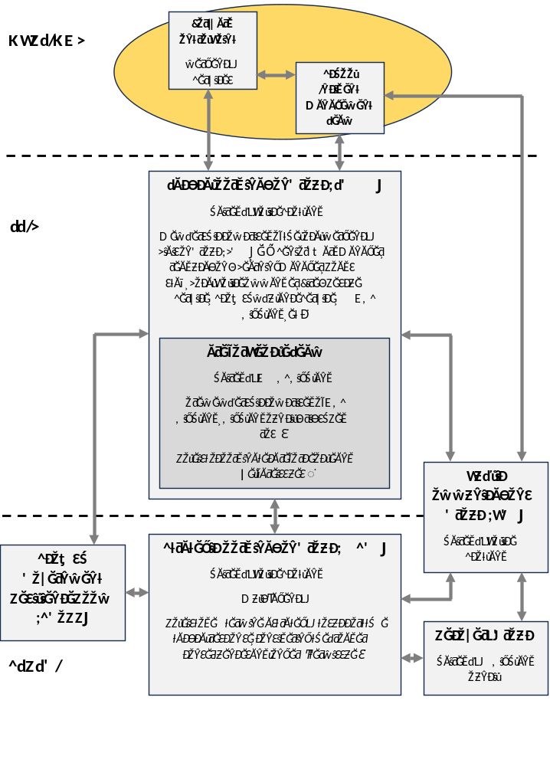

9. ROLES AND RESPONSIBILITIES

9.1 OPERATIONAL LEVEL: School Incident Management Team

When a Major Incident occurs either within a school, involving school transport or on a school trip, the Operational Level is the first level of response. Immediately a School Incident Management Team (SIMT) should be set up. The job of the SIMT is to respond to the immediate effects of any incident.

The following will make up the School Incident Management Team:

9.1.1 Co-ordinator

There should be someone previously identified as the SIMT co-ordinator, preferably the Head Teacher or Depute Head Teacher. They will:

- Confirm that there is an emergency.
- Determine the appropriate level of response for an incident by way of
existing Health and Safety guidelines. It may be appropriate to either evacuate or lockdown school premises, in which case refer to the relevant procedures. Ensure school staff are performing the necessary roles to achieve this.
- If necessary, clear the area. Arrange with the Area Education & Learning Office to keep the pupils in school / send home / or to the designated emergency Reception Centre (Appendix O).
- If the school is to be evacuated, contact the key holder of the designated emergency Reception Centre in preparation to receive pupils and staff.
- Control the situation:
- Coordinate and direct the activities of the SIMT.
- Arrange the distribution of the contents of the emergency kit bag accordingly (Appendix E) (if available).
- Consider the need to alert other colleagues and external agencies (See
Appendices B1 & B2).
- Liaise with Police Scotland and other Emergency Services.
  - Brief the Council’s Corporate Communications & Resilience Manager in preparation for handling media enquiries and working with Police Scotland Media.
- Provide regular staff briefings to communicate policy, tactics and strategy.
- Keep a comprehensive log of information received, relayed and actions
taken.

9.1.2 Deputy Co-ordinators

- Assist the coordinator in alerting colleagues and establishing the SIMT.
- Coordinate and manage the staff in the SIMT.
- Help to keep all staff regularly updated.
- Monitor staff welfare.

9.1.3 Teachers

- Evacuate/lockdown the building as necessary.
- Maintain supervision.
- Ensure pupil safety.
- Provide information and offer reassurance.
- Monitor pupils’ physical and psychological welfare.
- Account for all students’ whereabouts.

    - Janitor / Facility Management Assistant

- Assist with opening or closing appropriate parts of the school. Depending on if evacuation or lockdown is required.
- Ensure site security.
- Provide information about site facilities/layout as necessary.
- Assist with traffic and crowd control.
- In the event of evacuation check all classrooms in conjunction with
teachers, providing it is safe to do so, to be sure that no on has been left in the building.
- Liaise with the Emergency Services.

9.1.5 Media

  - Refer all media enquiries to the Council’s Corporate Communications & Resilience Manager, or to Police Scotland Media if the police have taken control of the incident.
  - In liaison with the Council’s Corporate Communications & Resilience Manager, the Head Teacher or Depute Head Teacher may be required to speak to the media and would be advised and supported accordingly.

9.2 OPERATIONAL LEVEL: Emergency Services, etc.

When the police arrive, they will take control of the incident and coordinate the response. The at-scene response will be managed from a Forward Control Point (FCP), established following consultation between Police Scotland and the Fire and Rescue Service as necessary.

Until then, it is up to the SIMT to manage the situation. Once assistance arrives SIMT will work with Police Scotland and other responding agencies.
9.2.1 Police Scotland

Responding to emergencies is a normal feature of the work of Police Scotland. The normal role and responsibilities of the police encompass the protection of life and property. They will:

- Save life in conjunction with the other Emergency Services.
- Protect and preserve the scene.
- Call out or place on standby essential services.
- Collate and disseminate casualty information.
- Identify the dead on behalf of the Procurator Fiscal who is the principal
investigator when fatalities are involved.

9.2.2 Fire and Rescue Service

- Tackle fires and deal with released chemicals and other hazardous
situations to save life and protect property.
- Rescue trapped casualties.
- Liaise with the Medical Incident Officer and other medical services with
regard to the provision of assistance at ambulance loading points and the priority evacuation of injured persons.

9.2.3 Scottish Ambulance Service (SAS)

- Save life and provide immediate care to patients at the scene of a major incident and in transit to hospital.
- Alert hospital services and immediate care GPs.
- Manage any decontamination of people affected by hazardous substances, prior to evacuation from the scene.
- Evacuate the injured from the scene in order of medical priority.
- Alert and co-ordinate the work of the Voluntary Aid Societies acting in support of the SAS at the incident site (e.g. British Red Cross).

9.2.4 NHS Highland

- Provide a Medical Incident Officer and appropriate medical services at the incident site.
- Provide a Site Medical Team if required at the incident site.
- Provide medical treatment and health care to casualties.

9.3 TACTICAL LEVEL

If required, a Tactical Coordination Group (comprised of local Emergency Liaison Group members) will be set up to support the work of school staff, the Emergency Services and other agencies at the scene of the incident. The school will receive direct assistance from its Area Education & Learning Office. It is the Area Education & Learning Office that you should keep updated as the incident develops, and seek help from with school management issues.

Every incident is unique. However, the following demonstrates the actions that can be expected at tactical management level.

9.3.1 Area Education & Learning Office

- Alert the appropriate people, including the relevant Senior / Ward Manager (see Appendices B1 & B2).
- Make arrangements for school closure, partial closure, change of venue, changes to transport and school meals, as necessary.
- Following liaison with Police Scotland and the school, arrange for families/ guardians of pupils and staff involved in the incident to be contacted.
- In the event of a school trip, make arrangements for pupils to come home earlier, if required.
- To deal with any other matters raised by the Head Teacher and requiring assistance.
- Keep the Executive Chief Officer for Education & Learning regularly updated.
- Contact appropriate others, including:
      - Suppliers
      - Expected Visitors
- Arrange for ongoing support of pupils, staff and their families.
- Attend (in person / via MS Teams) any Tactical Coordination Group meetings.
- Assist in any other way as appropriate, depending on the incident.

9.3.2 Highland Council Resilience Team

- Liaise with Chief Executive and Corporate Emergency Management Team (CEMT).
- Monitor, evaluate and anticipate requirements of the response.
- Where possible, attend (in person / via MS Teams) any Tactical Coordination Group meetings.
- Assist with establishment of a Council Tactical Group, as required.
- Assist Education & Learning Service with further emergency needs.
- Advise on the establishment of a Reception Centre, if necessary.

9.3.3 Highland Council Corporate Communications Team

- Liaise with Chief Executive, Duty Executive Chief Officer, Corporate Emergency Management Team (CEMT) and other relevant staff.
- Where possible, attend (in person / via MS Teams) Tactical Resilient Partnership meetings.
- Assist with establishing a Media Liaison Point, if appropriate.
- In liaison with Police Scotland, be responsible for any dealings with the media.
- Arrange media briefings, conferences and press statements.

9.3.4 Senior / Ward Manager

- Support the Council’s tactical response at the local level.
- Brief affected Ward Member(s).
- Where possible, attend (in person / via MS Teams) Tactical Coordination Group meetings.

9.3.5 Educational Psychologists

- Provide advice to parents, staff, agencies and others of the possible psychological effects of an incident on the pupils and staff involved, as well as the potential impact on others not directly affected.
- Facilitate appropriate support for pupils and staff.

9.3.6 Resources and Finance

- Determine who will authorise additional expenditure, to what limits and how emergency funds will be accessed.
- Make available funds to cover immediate expenses where required.
- Co-ordinate necessary expenditure and credit arrangements.
- Keep a record of all expenditure throughout the period of the incident.

9.3.7 Communities and Place

- Environmental Health to advise / respond to incidents involving communicable illness or disease.
- Take action to safeguard the public against environmental conditions which are prejudicial to public health – including chemical spillages, pollution monitoring and provision of clean water supply.
- Where possible, relevant staff to attend (in person / via MS Teams) any Tactical Coordination Group meetings.

9.3.8 Infrastructure, Environment and Economy

- Roads & Transport to assist Police Scotland with traffic and crowd control measures by erecting diversion signs and temporary barriers.
- Where possible, relevant staff to attend (in person / via MS Teams) any Tactical Coordination Group meetings.

9.3.9 Property and Housing

- Provide help to identify temporary accommodation and furniture.
- Deal with building needs (e.g. repairs) generated by the incident.
- Provide civil engineering appraisal and advice.
- Where possible, relevant staff to attend (in person / via MS Teams) any Tactical Coordination Group meetings.

9.3.10 Performance and Governance

- Liaise with Education and Learning to identify and deal with any legal matters and / or restrictions that may be apparent either during the incident or the recovery phase.
- Assist the Council and school, if at a later stage there is an inquiry or
legal action.

9.3.11 Police Scotland

- Chair Tactical Coordination Group meetings during the emergency phase of the incident.
- Coordinate the Emergency Services and other responding agencies during the emergency phase of the incident.
- Coordinate media during the emergency phase of the incident in liaison with the Council’s Corporate Communications & Resilience Manager.
- Coordinate investigations on behalf of the Procurator Fiscal.
- Assist The Highland Council with recovery issues at the earliest opportunity.

9.3.12 Fire and Rescue Service

- Liaise with other tactical responders to develop a strategy to control, contain and mitigate the effects of the incident.
- Ensure the continued safety at and around the site.
- Attend (in person / via MS Teams) any Tactical Coordination Group meetings.

9.3.13 Scottish Ambulance Service (SAS)

- Liaise with other tactical responders to develop a strategy to control, contain and mitigate the effects of the incident.
- Ensure the supply of adequate patient care equipment, patient transport and provision of appropriate medical staff to the scene of the incident.
- Attend (in person / via MS Teams) any Tactical Coordination Group meetings.

9.3.14 NHS Highland

- Chair the Care for People Team and coordinate Care for People arrangements for wider public affected by the incident.
- Liaise with other tactical responders to develop a strategy to control, contain and mitigate the effects of the incident.
- Ensure that overall health care needs are met.
- Provide appropriate support for the joint agency media arrangements.
- Issue health care advice to participating agencies and the public.
- Attend (in person / via MS Teams) any Tactical Coordination Group meetings.

9.4 STRATEGIC LEVEL

Whist the Operational and Tactical levels deal with the immediate effects of an incident, it is important not to overlook the wider and longer-term issues. This is where the Strategic Level comes into play. In the event of a Major Incident, the role of Strategic responders is to explore and devise a strategy to deal with the broader consequences.

9.4.1 Chief Executive and Directorates

- Look at ways to continue educating pupils as soon as possible.
- Arrange to notify appropriate others including:
  - Chair and Vice Chair of the Education, Children & Adult Services Committee
  - School Board Chairman
  - Member of Scottish Parliament and Member of Parliament
- Liaise with Resources and Finance regarding expenditure and any proposed appeals.
- Make arrangements for expressions of sympathy and / or acknowledgement of what has happened.
- Plan memorials and commemorations.
- Prepare and deal with Royal and Protected People visits, as required.
- Ensure normal Council business continues as far as possible.
- Explore any other long-term issues.
- Continue to keep a record of continuing issues and actions.
- Liaise with the Council’s Corporate Communications & Resilience Manager, who will work with Police Scotland and other agencies to determine an overall media strategy.
- Attend (in person / via MS Teams) Strategic Coordination Group and Recovery Group meetings, as required.

9.4.2 Emergency Services and NHS Highland

- Chief Officers, Director of Public Health and media officers determine an overall strategy that is appropriate to the particular circumstances.
- Attend (in person / via MS Teams) Strategic Coordination Group and Recovery Group meetings, as required.

9.4.3 Central and other Government Agencies

    - Provide advice and assistance.
- Attend (in person / via MS Teams) Strategic Coordination Group and Recovery Group meetings, as required.

Recovery Group

A Recovery Group will be commissioned at the outset of most Major Incidents. The Recovery Group, under the leadership of the Executive Chief Officer for Education & Learning (or other appropriate individual) and comprising such officers from Highland Council and other agencies as required, will supervise the return to normality. The role of the Recovery Group is to enable the rebuilding, restoration and rehabilitation of the community and environment following a major incident.

The Recovery Group may initially be co-located with the Strategic Coordination Group at Divisional Police Headquarters, Inverness, otherwise it will meet virtually via MS Teams. Once the emergency response is over, control of the incident will formally pass to The Highland Council. If the Recovery Group is required to meet in-person it will, in most cases, be accommodated in Council HQ, Glenurquhart Road, Inverness, otherwise it will continue to meet virtually.

For Scottish Government guidance on recovery from emergencies, see Preparing Scotland – Recovering from Emergencies in Scotland (Sept 2017)

For further information, also refer to the Highlands and Islands Local Resilience Partnership’s Recovery Guidance – Recovery: A Guidance Document for the Highlands & Islands Councils.

10. SCHOOL EMERGENCY PROCEDURES

On discovery of an incident, assess the situation, considering your own safety first, and take the following action.

Remove people from the danger area. Take care to ensure that this does not expose staff or pupils to other unnecessary danger.

- If it is safe to do so, Assemble everyone in one place. The names of those present must be checked against the register list.

- Summon the Emergency Services as quickly as possible (via 999). Whoever makes the call must ensure the following information is readily available:

  - Nature of the incident
  - Emergency Services required
  - Exact location of the incident
  - Numbers of casualties (if possible) and/or nature of injuries
  - Location and telephone number where call is being made from
  - Hazards which may be encountered by the Emergency Services at the site

- Alert will be initiated by the first person discovering the incident. ALL emergency situations must then be reported to the Head Teacher or Depute Head Teacher in the school by the quickest means possible.

- All schools have site-specific procedures describing the actions to be taken in the event of a school evacuation. A template Overview Sheet for Staff is provided in Appendix A. These procedures should be carried out appropriately.

- Head Teacher (or nominee) rings the Area Education & Learning Manager to support the school as necessary (see Appendix B1).

- Having validated and assessed the available information, the Area Education & Learning Office will determine the level of response required and arrange for internal and external alerts to be simultaneously initiated.

- Following advice from Education & Learning Service, the Council’s Resilience Team in conjunction with the Duty Executive Chief Officer, will implement all or part of the Council’s General Emergency Plan, or alternatively the incident will be dealt with via the normal departmental procedures.

- Key personnel will be alerted using the cascade system as described in Appendix B1.

11. SCHOOL TRIP EMERGENCY PROCEDURES

What follows is given by way of guidance for the initial response to an emergency during a school trip. This may need to be adapted to suit the situation.

Each adult member of the party should hold a copy of this guidance.

Establish the nature and extent of the emergency.

- Call the appropriate Emergency Services (all adults in the group should have previously been briefed on how to contact the Emergency Services for the country which they are in) and ascertain any additional contact numbers for future calls. Try not to rely solely on mobile phones.

- Decide who is in charge and allocate responsibilities to each adult member of the group.

- Make sure all members of the party are accounted for.

- Establish the names of any casualties and get immediate medical attention. Produce UK Global Health Insurance Card or UK European Health Insurance Card, if appropriate.

- Ensure, if possible, that a teacher accompanies casualties to hospital with any relevant medical information. If there is only one adult at the site he/she must remain with the uninjured pupils.

- Ensure that all group members who need to know are aware of the incident.

- Ensure that remaining pupils are supervised and arrange for a return to base as early as possible.

- Arrange for an adult to remain at the site of the incident to liaise with the Emergency Services until the incident is over.

- Contact Head Teacher or Depute Head Teacher acting as school contact and link between the group and Area Education & Learning Office (see Appendices B1 & B2). Give full details of the incident, including:

  - Name of person making call
  - Nature, date, location and time of the incident
  - Names of person(s) injured / taken to hospital
  - Actions taken so far
  - Contact telephone number(s)

- Ensure the British Embassy / Consulate has been informed if the emergency has occurred abroad.
- No member of staff or pupil should discuss matters with the media. Refer media enquiries to the Council’s Corporate Communications Team (corporate.communications@highland.gov.uk)

- Schools should be mindful of school messages on school social media. Pupils should also be advised on what messages they place on social media.

- The party leader should, at the first opportunity, make notes on the incident, as should all other staff involved. A record should be made of the names & addresses of any witnesses or people outwith the party who were involved.

- Legal liability must not be discussed.

12. SCHOOL LOCKDOWN PROCEDURE

All schools should consider the need for robust and tested school lockdown procedures.

Lockdown procedures should be seen as a sensible and proportionate response to any external or internal incident which has the potential to pose a threat to the safety of staff and pupils in the school. Procedures should aim to minimise disruption to the learning environment whilst ensuring the safety of all pupils and staff. Lockdown procedures may be activated in response to any number of situations, but some of the more typical might be:

- A reported incident/civil disturbance in the local community (with the potential to pose a risk to staff and pupils in the school).
- An intruder on the school site (with the potential to pose a risk to staff and pupils).
- A warning being received regarding a risk locally, of air pollution (smoke plume, gas cloud etc.) or chemical, biological or radiological contaminants.
- A major fire in the vicinity of the school.
- The close proximity of a dangerous dog / animal roaming loose.

12.1 Lockdown Arrangements

Lockdown arrangements should be determined by schools on an individual basis, as they will be dependent to a large extent on local circumstances such as premises design and layout, class arrangements, resources available, etc.

Schools should consider having two types of lockdown; ‘partial’ and ‘full’.

12.1.1 Partial Lockdown

Alert to staff: ‘Partial lockdown’

In a partial lockdown staff and pupils should remain in the school building and all doors leading outside should be locked and windows closed.

No one should be allowed to enter or leave the building; however teaching and work can continue as usual.

This may be as a result of a reported incident / civil disturbance in the local community with the potential to pose a risk to staff and pupils in the school. It may also be as a result of a warning being received regarding the risk of air pollution, etc.

Immediate action

- All outside activity to cease immediately, pupils and staff return to building. (There needs to be a means of communicating the alert to duty staff at break times).

- All staff and pupils remain in building and external doors and windows locked.

- Free movement may be permitted within the building dependent upon circumstances.

- In the event of an air pollution or chemical, biological or radiological contaminants issue, air vents, fans, heating and air conditioning systems should be closed or turned off. Use anything to hand to seal up all the cracks around doors and any vents into the room – you aim to minimise possible ingress of pollutants. Staff should await further instructions. All situations are different. Once all staff and pupils are safely inside, senior staff will conduct an ongoing and dynamic risk assessment based on advice from the Emergency Services. Inform your Area Education & Learning Office.

A ‘partial lockdown’ may also be a precautionary measure, but puts the school in a state of readiness (whilst retaining a degree of normality) should the situation escalate.

Emergency Services will advise as to the best course of action in respect of the prevailing threat.

12.1.2 Full Lockdown

Alert to staff: ‘Full lockdown’

This signifies an immediate threat to the school and may be an escalation of a partial lockdown. The aim of a full lockdown is for the school and its rooms to appear empty.

Immediate action

- All pupils / staff stay in their classroom or move to the nearest classroom.

- Office staff should remain in their office.

- External doors locked. Classroom doors locked (where a member of staff with key is present).

- Windows locked, blinds drawn, internal door windows covered (so an intruder cannot see in).
- Pupils / staff sit quietly out of sight and where possible in a location that would protect them from gunfire (bullets go through glass, brick, wood and metal. Consider locations behind substantial brickwork or heavy reinforced walls).

- Lights, smartboards and computer monitors turned off.

- Mobile phones turned onto silent so they cannot give away your position.

- A register to be taken of all pupils / staff in each classroom/office.

- Communicate register of staff / pupils to a pre-agreed central office.

- Staff should await further instructions.

Staff and pupils remain in lock down until it has been lifted by a senior member of staff / Emergency Services. At any point during the lockdown, the fire alarm may sound which is a cue to evacuate the building.

During the lockdown, staff will keep agreed lines of communication open but not make unnecessary calls to the central office as this could delay more important communication.

Examples of discreet communication channels might be:

- Where staff have access to an internal email system, they could access their account and await further instruction. In practical terms, staff would need to be familiar with accessing their account through a variety of means e.g. laptop, smartphone or tablet.

12.2 School Lockdown Plan

It is not possible to prescribe a generic school lockdown plan in this document as there are a number of variables that will dictate exactly how an individual school responds to those situations identified, for example:

- Access to school bell controls to raise an alarm in an emergency.
- Other means of internal communications - messenger, two-way radios, mobile phone, internal email, texts etc.
- School site plan e.g. the layout of buildings and their proximity to one another.
- Age of students.
- Geographical location – urban / rural, presence of secure perimeter fence.

Nonetheless, many schools have found it helpful to incorporate the following basic principles in their plans:

- A member of staff is nominated as lockdown manager (plus deputies in their absence) to initiate, manage and conclude the lockdown. They will also communicate with Emergency Services. Their roles and responsibilities should be documented.
- Staff are alerted to the activation of the plan by a recognised signal, audible throughout the school.
- The use of the fire alarm should be avoided to reduce the incorrect response to an incident.
- Pupils / staff who are outside of the school buildings should be brought inside as quickly as possible.
- Those inside the school should remain in their classrooms or proceed directly to the nearest classroom.
- All external doors and, as necessary, windows are locked (depending on the circumstances, internal classroom doors may also need to be locked).
- Blinds/curtains drawn and windows on internal doors covered.
- Once in lockdown mode, staff should notify the office immediately of any pupils not accounted for and any additional pupils / staff in their classroom via the agreed communication channel.
- Staff should encourage the pupils to keep calm.
- As appropriate, the school should establish communication with the Emergency Services as soon as possible.
- The Highland Council should be notified via the Area Education and Learning Office or if unavailable the Duty Executive Chief Officer on 01349 886677.
- If necessary, parents should be notified as soon as it is practicable to do so via the school’s established communications system.
- Pupils must not be released to parents during a lockdown.
- If it is necessary to evacuate the building, the fire alarm should sound.
- Ensure procedures are in place for members of staff who do not have a regular office or classroom.
- Ensure visitors / volunteers / peripatetic staff are included in your school lockdown plan.
- Establish as official lockdown termination announcement/signal so that all staff know that it is authentic.
- Specific arrangements should be made for pupils / staff with different needs (e.g. hearing / visual impairment or mobility needs).
- Areas in the school that cannot be effectively locked down should be identified and the lockdown procedures should include instructions on removing staff and pupils from these areas to a place of safety (e.g. toilets / outbuildings).
- Establish agreed methods of communication from staff to the lockdown manager should a dangerous intruder be located on the school premises.
- An overview sheet outlining the school’s procedures will be displayed in the staffroom and other places throughout the school as appropriate (see Appendix A).
- Lockdown procedures should be tested and practised at least once early in the school year.

In the event a school is in lockdown and the fire alarm sounds, the school should contact the Emergency Services as in a normal fire alarm activation. A nominated member of staff who has a means of remote communication (e.g. a walkie talkie) should go to the fire alarm panel to establish what zone has been activated. Once the zone has been identified, the alarm should be silenced and another person sent to the area to investigate. They will need to approach with caution as there may be a fire or an intruder may have activated the alarm. If a fire is discovered this information should be communicated back to the person at the fire alarm panel, who should re-sound the alarm, update the Emergency Services and evacuate the school.

Due to the fast moving nature of incidents that require lockdown, it is important that all staff are able to act quickly and effectively. Staff should have clear roles and responsibilities and it is of vital importance that the school’s lockdown procedures are familiar to members of the senior management team, school administrators, teaching staff and non-teaching staff. Depending on their age, pupils should also be aware of the plan. (Regular practices will increase their familiarity).

Staff’s understanding should be regularly checked with regular training refreshers. A lockdown drill should be undertaken at least once a year and thoroughly debriefed to monitor the effectiveness of your arrangements. Parents too should know that the school has a lockdown plan and that it will be regularly tested. However, it is not advisable to share the school’s full lockdown plan or to make this public.

It would also be good practice to:

1. Conduct a number of table-top exercises with the senior leadership team to test the procedures against various scenarios.
2. Rehearse lockdown arrangements with all staff and pupils.
3. Display lockdown drill information in every classroom alongside information relating to fire drills.

12.3 Communication between Parents and the School

Arrangements for communicating with parents in the event of a lockdown, should be shared either via newsletter or the school website.

In the event of an actual lockdown, it is strongly advised that any incident or development is communicated to parents as soon as is practicable. It is obvious that parents will be concerned but regular communication of accurate information will help to alleviate undue anxiety

Parents should be given enough information about what will happen so that they:

- Are reassured that the school understands their concern for their child’s welfare, and that it is doing everything possible to ensure his/her safety.
- Do not need to contact the school. Calling the school could tie up telephone lines that are required for contacting emergency support providers.
- Do not come to the school. They could interfere with emergency support provider’s access to the school and may even put themselves and others in danger.
- Wait for the school to contact them about when it is safe to collect their children, and where this will be from.
- Are aware of what will happen if the lockdown continues beyond school hours.

The ‘communication with parents’ section of the school lockdown plan needs to reassure parents that the school understands their concern for their children’s welfare and that everything that can possibly be done to ensure children’s safety will be done. However, it may also be prudent to reinforce the message that ‘the school is in a full lockdown situation. During this period the switchboard and entrances will be un-manned, external doors locked and nobody is allowed in or out…’

Should parents present at the school during a lockdown, under no circumstances should members of staff leave the building to communicate directly with them.

12.4 Emergency Services

It is important to keep lines of communication open with Emergency Services as they are best placed to offer advice as a situation unfolds. The school site may or may not be cordoned off by Emergency Services depending on the severity of the incident that has triggered the lockdown. Emergency Services / Police will discuss the timing of communication to parents with the Head Teacher.

In the event of a prolonged lockdown or more severe scenario, Emergency Services, local authorities and voluntary sector organisations will work together to co-ordinate practical and emotional support to those affected by any emergency, also referred to as humanitarian assistance. A Reception Centre for friends and family could be set-up by the Council in liaison with Police and other Emergency Services outside of the cordoned area.

13. COMMUNICATIONS

One of the greatest demands during an emergency is for information and regular updates. People want to know what has happened and what is going to happen next. This means that the needs of a crisis will place a great strain on existing communications, especially as many smaller schools have only one telephone line. Clear lines of communication are crucial in the successful response to a crisis.

13.1 Extra Resources

In addition to the school’s established system(s) for communicating with parents, the Council’s Corporate Communications Team may update social media channels with any relevant information regarding the emergency.

See Appendix F for the inventory of resources detailing the available communications facilities available within the school.

14. MEDIA

Depending on the nature of the incident the media are likely to contact the school by phone or be present at the school within a very short space of time. They can be very intrusive and will approach anyone to give them a story. The school must aim to protect pupils, staff and parents from the glare of publicity, particularly in the initial stages following an incident.

Please be aware that Police Scotland is responsible for co-ordinating media during the emergency response.

14.1 Media Relationship

A good relationship with the media is essential and will help to avoid:

- Inaccurate information being broadcast or published, which might lead to unnecessary upset, public alarm or concern.

- Intrusion into the privacy rights of any members of the school.

- The risk of jeopardising any future investigation or enquiry.

The media is an excellent way of:

- Raising awareness of an incident.

- Obtaining vital information from the public.

It is therefore essential to have a pro-active strategy for managing the media whether they are local, national or international.

14.2 Guidelines for School Staff

Staff must be prepared to deal with the media who will be trying to get live coverage, pictures and interviews. It is not advisable to permit the press and television crews onto school premises or to give them access to staff or children. Staff must be regularly reminded that all enquiries should be directed to and through the Council’s Corporate Communications & Resilience Manager, or Police Scotland Media if the police have taken control of the incident.

All news releases must be cleared and issued through the Council’s Corporate Communications Team
(email: corporate.communications@highland.gov.uk)

14.3 Media Liaison Point

The purpose of the Media Liaison Point is to provide a focal point for journalists, camera crews and photographers who want to get as close as possible to the scene, while at the same time segregating them from those people who may have been caught up in the incident. The Media Liaison Point will help to co-ordinate media response at a local level and provide a hub for the distribution of news releases and information packs.

If required, a Media Liaison Point will be established at a suitable location in conjunction with the Council’s Corporate Communication’s Team and Police Scotland.

14.4 School Spokesperson

There should be a designated school staff member who, if required, is able to speak with the media when a school related incident occurs. This role would normally be fulfilled by the Head Teacher or Depute Head Teacher.

Before speaking to the media, the school spokesperson must take advice from the Council’s Corporate Communication’s Team.

15. NOTIFYING PARENTS

Following a major incident schools need to ensure that they are communicating effectively with parents in order to allay fears and minimise concern or disruption. Parents also need to be guided to ensure they do not distract Emergency Services and school staff from doing their jobs.

Reference should be made to the School Incidents Communication Guidance in Appendix G.

15.1 Notifying Parents

Schools must liaise with the Area Education & Learning Office prior to issuing information to parents, particularly where there is the possibility of legal liability, police action or a significant health issue.

It is important to remember the following:

- Be sensitive, honest and caring.
- Provide factual information.
- Treat parents of the injured as individuals, not members of a group.
- Confidentiality and data protection.
- Restrictions around police investigations.

15.2 Methods of Informing

The method of communication will be determined by the nature of the incident. In some circumstances a phone call or a letter home (see Appendix J) with the pupils would be appropriate. In other cases, a meeting with parents may be required. In the event of a Major Incident involving death, it will always be the police who will inform the next of kin.

This has to be done as soon as possible and with sensitivity. For this reason, it is obviously necessary to have parent’s contact details regularly checked and kept up-to-date.

15.3 Advice on Telephoning

- Select staff members and brief them on the exact information to be given out.
- Get the calls done quickly – misinformation in the absence of specific knowledge can spread informally very quickly.
- Keep records of who has been contacted successfully.
- Give parents clear information and advice about what they should do next.
- Offer useful phone numbers for support or to obtain more information (e.g. an emergency helpline, if established).

15.4 At the Scene

If the incident occurred at school and the parents are gathered near the scene, try to separate them from other onlookers and the media, then inform to reassure them. Try to keep them calm and keep them from interfering with the work of the Emergency Services and other such staff.

15.5 Briefing Staff

It is necessary to keep staff briefed so that they may respond to questions and comments from pupils. This is best done in a structured way at pre-determined times.

15.6 Informing Pupils

It will be a matter of judgement in relation to what information is conveyed to pupils, though there should be consistency in the information provided. Care must be taken to ensure that children who may be vulnerable are treated accordingly. The Council will provide support and guidance if required.

16. LOGGING EVENTS

It is essential that everyone involved in responding to an emergency, starts and maintains a written log as soon as possible. The information contained in these logs will prove extremely useful. They will enable your school to provide detailed information should it be required at a later stage, in preparing for debriefs or reports, and may be called upon in any subsequent inquiry or legal action. It will also be useful for a post-incident review.

16.1 During an Incident

The incident log must be maintained from the beginning to the end of the incident.

The incident log should include:

- Date and time of actions
- Decisions
- Information
- Messages received.

A suggested form for this purpose is included in Appendix K.

16.2 After an Incident

When an incident is over these logs should be copied to: -

- The Head Teacher, who will forward a school log of events to the Area Education & Learning Manager.

- If necessary, the Area Education & Learning Manager will arrange for a copy of the school log to be passed to the Council’s Resilience Team.

17. TRAINING AND EXERCISING

Training and exercising are vital parts of the emergency planning process. It is of limited value having plans in place if people are not trained to perform in accordance with required procedures. Wherever possible, people should be called upon to perform in an emergency the type of task with which they are already familiar – normal roles in exceptional circumstances. This approach:

- Makes maximum use of the existing skill base.
- Is more likely to lead to effective performance when under the additional pressure of an emergency.

17.1 Training

Training is more personnel focused, aiming to provide staff with the required information about the policy and plan and enhancing their knowledge, skill and experience.

Appropriate training should be given to people before they are asked to take part in exercises, particularly for those who exercise key roles. This entails more than simply informing people that they should be familiar with the contents of emergency plans! Training will give them the opportunity to familiarise themselves with key issues and arrangements, appreciate and practice relevant activities and develop the required skills.

17.2 School’s Role

Schools should carry out their own training. All schools practice fire drills but schools must consider practicing other unforeseen instances with pupils and staff. In addition, schools must consider having training sessions with all staff to familiarise them with the plan and the school’s procedures for different emergency scenarios.

Training activities for emergency plans and response activities will be conducted on a continuous basis for all pupils and staff. Training will be revised as necessitated by plan changes or experience in actual events. Remember to be inclusive, as everyone has a role in an effective emergency plan. The records of training must be maintained and monitored to ensure that the information is current (see Appendix L).

Training provides the foundation upon which exercising can then take place.

17.3 Exercises

Conducting exercises can be a broader approach examining all aspects of that policy and plan, not just the human response but also physical and organisational capability to deal with a major incident, or it can concentrate on specific components.

Exercises are usually designed to:

- Clarify roles and responsibilities.
- Improve co-ordination.
- Improve individual response / proficiency and build confidence.
- Test plans and systems, e.g. evacuation and lockdown procedures.
- Identify resource gaps.
- Identify areas for improvement.

The main types of exercises are:

- Seminars – workshops or discussion-based exercises.

- Tabletop exercises – floor plan exercises.

- Live exercises – practical, operational or field exercises.

17.4 Applying Training and Exercising

Always remember that generic planning is best rather than preparing detailed procedures for every eventuality. In most exercises the objective will be to test that arrangements and procedures are sufficiently flexible and adaptable to meet the circumstances on the day, and if not, to change the plan accordingly.

The level of training and exercising within a school will, by necessity be very basic and will be restricted to regular short meetings to ensure that the staff involved are aware of their responsibilities and to ensure that documentation, and contact numbers are up-to-date. However, more sophisticated training and exercising will not take a great deal longer than a simple meeting and must be carried out on a regular basis. The use of short awareness raising seminars, tabletop exercises and even live exercises will bring staff together to further and validate the planning process.

18. GLOSSARY

Casualty Clearing Station - A place where people with injuries will be taken in order to receive medical, triage and treatment.

Category 1 Responders – As defined in the Civil Contingencies Act 2004, Category 1 responders include Local Authorities, Police Force, Fire Authority, NHS Scottish Ambulance Service, Health Board, Coastguard and SEPA.

Category 2 Responders – Include: Utilities, Public Communications Providers, Harbour Authorities, Airport Operators, Health & Safety Executive and Health Protection Scotland. Category 2 Responders have a duty placed upon them to co-operate, co-ordinate and assist those in Category 1.

Civil Contingencies Planning – Application of knowledge, at all levels of management that measures and practices to anticipate, guard against, prevent, reduce or overcome any hazard, harm or loss that may be associated with natural, technological or man-made crises and disasters in peacetime.

Crisis Management - A continuous process in which all phases of the plan are being reviewed and revised. Good plans are never finished. They can always be updated based on experience, research and changing vulnerabilities.

Emergency – Any event or situation, which presents a serious threat to individuals or the environment, including death, serious injury or trauma, and may include major damage to property. These may be large scale affecting the whole locality or school, or smaller scale affecting one or two individuals within your school.

Emergency Planning – is the preparation of plans to be able to cater for any disruptive challenge.

Emergency Preparedness – Is being ready, to continue to operate the school, but at the same time to counteract the effects of an emergency. Good planning will facilitate a rapid, coordinated, effective response when a crisis occurs. Being well prepared involves an investment of time and resources – but the potential to reduce injury and save lives is well worth the effort.

Emergency Risk Management – a systematic process that produces a range of measures that contributes to the well being of communities and the environment.

Forward Control Point - A point at the scene where the Emergency Services come together to form a multi-agency response.

Media Liaison Point - A controlled point, on-site, where the media are able to take photographs and view the scene. It is also a place where press conferences, press releases and interviews can be held.

Hazard – An accidental or naturally occurring event or situation with the potential to cause physical (or psychological) harm to members of the community (including loss of life), damage to losses to property, and/or disruption to the environment or structures (economic, social, political) upon which a community’s way of life depends.

Media Centre - Act as a focus for information flows to and from the media and as a recognised and helpful point of contact.

Reception Centre – a place of relative safety where evacuees/uninjured survivors and other displaced persons have been moved.

Risk – those hazards (i.e. non-malicious events such as flooding) or threats (i.e. malicious events such as terrorist attacks) which could adversely affect a community or organisation and its ability to carry out its functions. Risk is a function of the likelihood and impact of a hazard or threat.

Threat – The intent and capability to cause loss of life or create adverse consequences to human welfare (including property and the supply of essential services and commodities), the environment or security.

Unusual Incident – Any incident arising with little or no warning which requires a response beyond the routine. The response may be managed wholly by the Council, perhaps with limited multi-agency assistance. It may also have the potential to escalate to a Major Incident.
APPENDIX A: OVERVIEW SHEET FOR STAFF

Raasay Primary School
Emergency Procedures

Fire Alarm

In the event of the fire alarm sounding (which is a continuous bell) please leave the school buildings by the nearest fire escape route and assemble on the road at the school gate.

‘Shelter in Buildings’ Alarm
In the event of five rings of the bell stay indoors, in the room/classroom that you are in. If you are outside when this bell sounds, make your way to the nearest classroom or hall.

If you are with children, it is important to:
- remain calm.
- reassure them.
- remind them to follow your instructions.

APPENDIX B1: CASCADE FOR SCHOOLS TO INITATE A RESPONSE DURING OFFICE HOURS
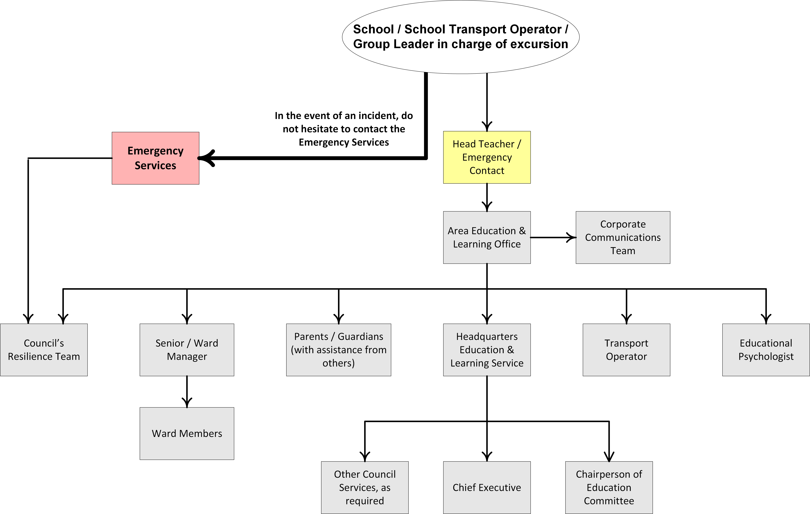

APPENDIX B2: CASCADE FOR SCHOOLS TO INITIATE A RESPONSE OUT WITH OFFICE HOURS

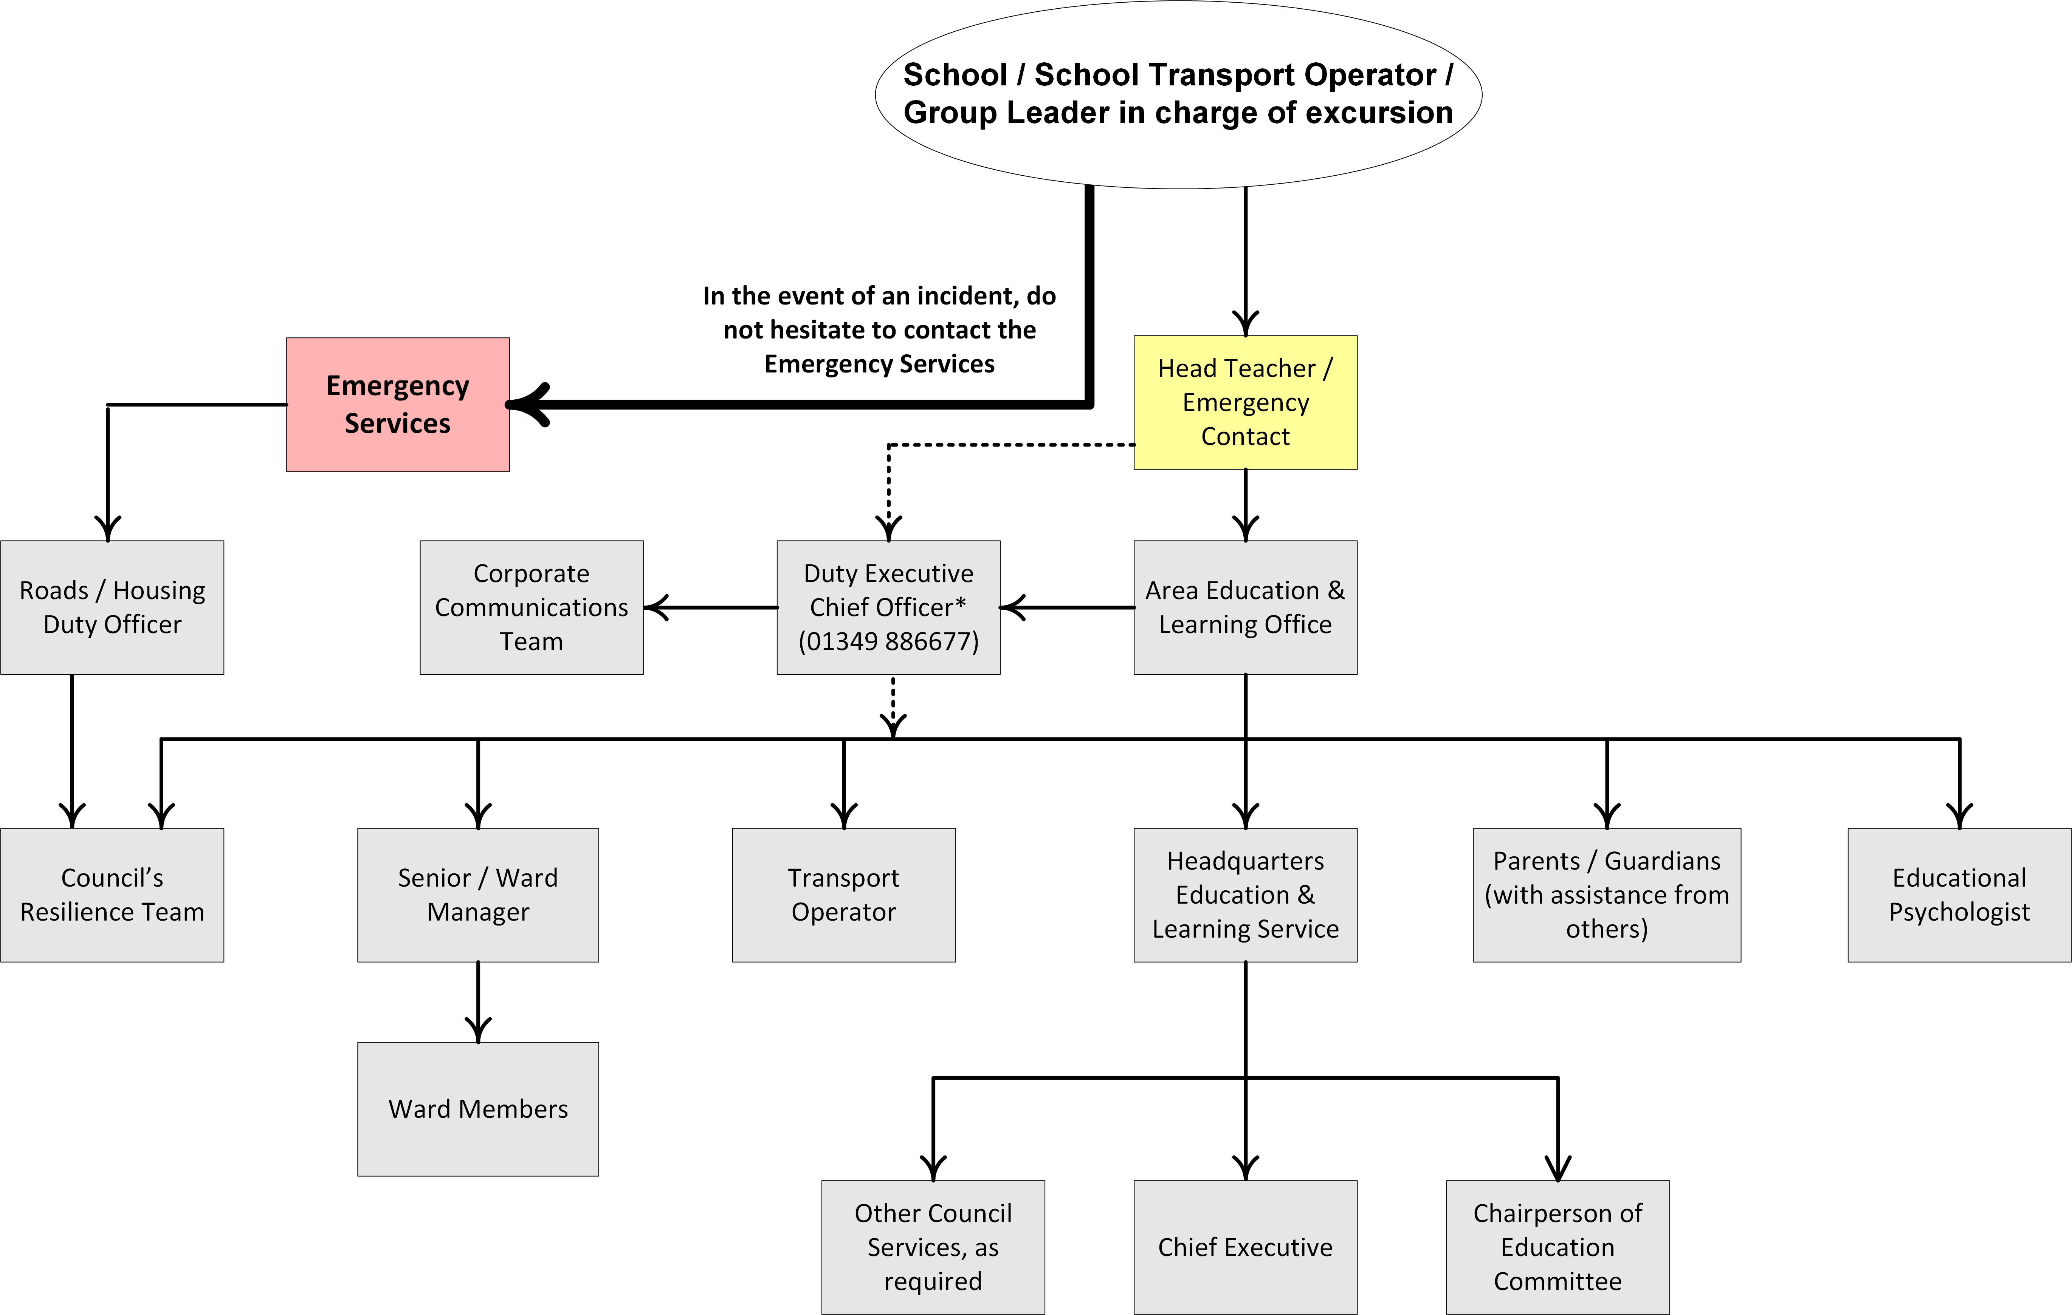

* The Council’s Duty Executive Chief Officer (Duty ECO) should always be contacted if the Head Teacher or designated Emergency Contact cannot reach the Area Education & Learning Office.

APPENDIX C: CASCADE FOR ALERTING SCHOOLS TO AN EMERGENCY INCIDENT

* During office hours, Area Education & Learning Managers should be alerted via their respective Area Education & Learning office. If this is not possible, an attempt should be made to contact the Area Education & Learning Manager directly.

The Head of Education must subsequently be informed of all incidents.

APPENDIX D: GUIDE TO DEVELOPING LOCKDOWN PROCESSES

This guide can be used by a planning group to develop lockdown procedures for your school. Results of the planning process may include a one-page procedure or simple set of steps for staff to follow in the event of a lockdown.

Procedures | Recommendations/Considerations
Phase 1  Develop the Procedures For Your School | - A small group may be useful to develop the plan (e.g. from admin and teaching areas)
- Nominate the people with authority to manage the lockdown.  - The nominated person will initiate, manage and conclude a lockdown | - Head Teacher, Depute and two others as back-up in case of absence.
- Define and list the circumstances in which your school will call a lockdown | - A lockdown should be initiated when a situation arises that requires the isolation (rather than evacuation) of staff and students from an identified threat.  - Threats to the safety of individuals on this site include; aggressive or violent intruder, siege/hostage incident, dangerous animals, armed robbery and lightning/severe storms.  - A lockdown should involve the whole school campus.
- Determine how individuals will contact the office if they see something suspicious.  - List the different methods for relevant areas e.g. intercom for classrooms, walkie talkie, mobile phone | - Review communications channels for whole school (tuckshop, isolated staff in satellite buildings, consider also groups returning from excursions etc.)  - How will Admin stay in contact and ensure nominated phone lines remain clear?  - Think about before & after school and during breaks.  - Do other communication options need to be purchased for playground duty etc. e.g. walkie talkies, UHF radios.  - Students should not be sent as messengers.
- Arrange how the lockdown alert signal will be given | - Ensure that it can be recognized / heard all over the school.  - An “alarm” sound is not recommended – this has the potential to agitate a person.  - If your school has the option to make an “announcement “e.g. a message or code this is preferred.  - Sound the signal but do not have it sounding continuously during the lockdown.  - The fire alarm should not be used as this would cause confusion and should be a signal to evacuate.
- Design a movement plan for students and staff to follow if they are not in a classroom.  - Develop a method for conducting the roll call and communicating information back to Administration | - Consider before and after school and the location of activities and play areas.  - Lunchtimes.  - Outdoor classes e.g. proceed to the closest, securable room.  - Isolated classes.  - Register all names of students, staff, volunteers etc. in each room or group.  - Collection of info e.g. Admin calls rooms in order or rooms dial in to Admin on nominated lines.  - Collate information at Administration and compare to school rolls etc.  - Keep intercom line free.
- Share the draft plan with staff and incorporate any relevant additions and changes | - A range of staff reviewing the document will often result in other issues being considered that may have been overlooked. Practical suggestions relevant for the school site may also be posed.
- Share and discuss the draft plan with the Area Education & Learning Office and RPO  - Determine capacity to assist control a situation.  - Inform them of the school’s planned approach.  - Gain their local knowledge. | - Review and integrate changes to facilitate a coordinated local community approach.  - Ensure contact procedures and details are up to date.
- Communicate and train staff in the procedure.  - Whole of school practice | - All staff at staff meeting or similar.  - All new staff on induction  - All supply teachers, playground supervisors.  - One page provided for each classroom (not displayed publicly)  - Practice (and review) at least once per year with different scenarios  - Depending on the age of the students, schools should consider whether it is necessary to send a letter to parents before & after lockdown drill to alleviate any concerns and ensure parents can be aware of children who may show signs of distress.  - E.g. Undertake the first practice on a student free day. Go to normal work areas and check that communications can be heard, rolls calling system is practiced etc. This can be helpful for staff prior to a practice with the entire student body.  - Invite local police to be involved in practice lockdowns.
- Document roles and responsibilities of the person in authority | Planning needs to consider:  - Signaling alert.  - Contacting police where relevant.  - Liaising with Area Education & Learning Office about support they can offer, e.g. diverting phones, providing information to parents, media support through Highland Council Corporate Communications.  - Contact Duty Executive Chief Officer and divert phones.  - Collect information about situation.  - Begin roll call procedure after X min. Consider procedure for lunchtimes etc.  - If in the event of stragglers – ensure there is a process in place to collect them e.g. Instructions if a student/other is in the toilet – to go to the nearest occupied room. Consider how this instruction in conveyed or Admin staff/teachers in areas go out to collect them.  - Liaise with Police.  - After incident contact Duty Executive Chief Officer, take advice from Corporate Communications, print letters for students to take home (see protocol for school emergencies).

Phase 2
Initiating a Lockdown Procedure
- Communicate the incident to Administration | - Try to give as much information as possible about what was seen.
- If no answer, instigate the lockdown procedure for your class or area | - Advise neighboring classes.  - Continue to hail administration area.
- On contact with Administration – a decision is made to instigate a lockdown
- Administration activates lockdown signal | - Communicate serious incidents resulting in lockdown to Police on 999.

Phase 3
Lockdown
Staff Role  - Mobilise staff and students (staff responsibilities)  - Roll Call | - If in class, stay in current classroom.  - If outdoors, move to closest, securable room or to designated area and stay.  - Check and collect people from adjacent/designated areas.  - Students and staff to stay out of sight as much as possible e.g. sit on floor.  - Turn off lights.  - Close windows and lock doors.  - Stay quiet.  - Staff remind students not to use mobile phones and turn off (to prevent texting).  - Note all students, visitors and volunteers that you have in your area.  - Advise administration (state how this is done for your school).  - Keep intercom and phone lines free – staff may be able to use mobile phones to assist.  - Ban texting / social media use – Emergency use only of mobile phones.
Administration/authority role  - Collect any information about incident/intruder etc.  - Communicate information to Police and take their instruction.  - Contact Area Education and Learning Office and divert phones to a pre-arranged number.  - Begin roll call process X minutes after lockdown was initiated. | - Advise staff if/when police are controlling the situation.  - Divert parents and returning groups from school etc.  - Ascertain if all staff, students and others are accounted for via roll call process.  - If not, round up any stragglers.
Continuing/extending lockdown  - Continue procedures of quiet sitting  - Take instructions from police if they have assumed control | - Continue mobile phone silence.  - Advise that no students can leave room for toilets, food etc.  - If toilet emergency for young child – use plastic lined rubbish bin. Some schools have a bucket, toilet paper & a sheet in each room in case of this type of emergency.  - If emergency medication is required – contact Administration for advice, assessment of the situation and to discuss options.

Phase 4
Lockdown Over
- Sound recognised audible signal to advise that the lockdown is concluded | - All clear signal should be given by person in control of the situation (Head Teacher or Depute).  - Police representative walk around to give all clear.
- Debrief students and staff | - Information for students / debrief (develop some staff information to talk through with students).  - Seek support from Resilience Officer for debrief.  - Brief staff meeting, advise of counselling support program over next couple of days.  - Provide HR Advisor contact details to all staff.
- Communication with parents, media | - Print out pre-prepared letters to send home with students. Advise parents that if they wish to discuss the issue further to please contact the Head Teacher.  - Admin to phone Duty Executive Chief Officer and Area Education & Learning Office to advise end of lockdown and outcomes.  - Sign out students if leaving before end of the school day.

Phase 5
Follow Up
- Documentation | - Check with your Area Education and Learning Office about reporting requirements.  - E.g. the Chief Executive Officer, Schools may require a report detailing the incident.
- Ongoing support, Guidance Officers etc. | - Immediate and ongoing e.g. 1 week, 1 month.
- Follow up and review procedures | - Review procedures, how did they work – what needs to be changed?  - Ask for feedback from staff about what working well and what did not.  - Update procedures as required, re-distribute and ensure all staff and others trained in new procedure.  - Update procedure.  - Practice again with new procedures.

APPENDIX E: EMERGENCY KITS

It is a good idea to have at least two emergency kits in every school, so if one is inaccessible due to the incident (e.g. fire) you can access the other. They should therefore not be placed close together but should be in secure locations, and accessible to all staff.

The Emergency Kits should comprise of:

- Emergency Procedures
- High Visibility Vests
- Hard Hats
- Blank Name Badges
- Stationery and Clip Boards
- Log Sheets
- School Fact File
- Loud Hailer
- Whistle

In the event of an incident the following should be accessed, where possible, and used to augment the emergency kits:

- First aid kit
- Emergency contacts and medical details for all students and staff
- Mobile phones and chargers
- Torches & batteries

APPENDIX F: INVENTORY OF SCHOOL RESOURCES

Communication facilities available during an emergency

(This page to be completed by the School)

Item | Where located | Notes
Telephones (s) | School Office  Main Classroom
Mobile Phones | All staff have personal mobile phones which they carry on them.  Nursery has designated school mobile which is carried by staff.
Photocopier | Main Classroom
Television | N/A
Whiteboards or flip chart | Smartboard and one wall mounted whiteboard in main classroom. Mobile flipchart available.
Computer with internet/email | School office, main classroom and nursery.
Stationary, supply of incident logs | Main classroom and office
School Fact File | School handbook available in office
Teachers Handbook | School office
Head Teachers Handbook | School office
Emergency Kit Bags  (Appendix E) | First Aid Room in main school (staff toilet)  First Aid Room in nursery (toilet)

APPENDIX G: COMMUNICATION GUIDANCE

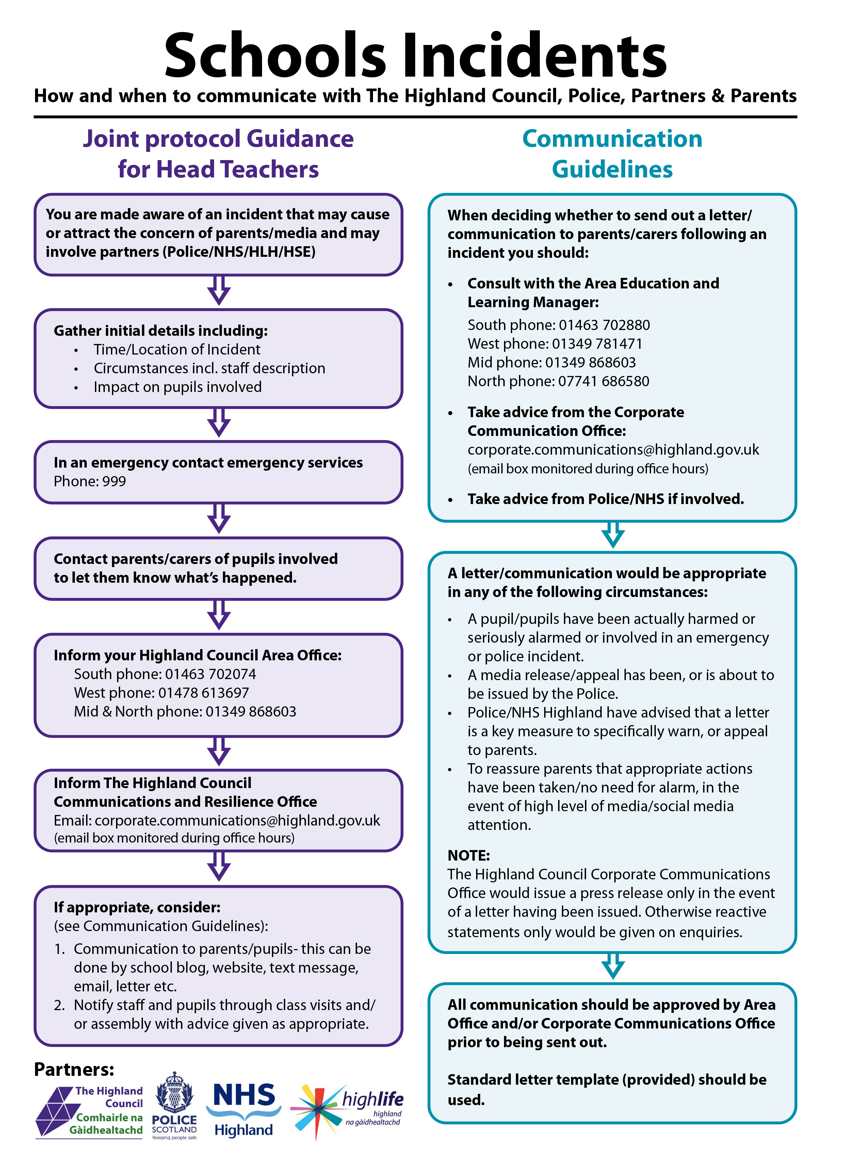

APPENDIX H: TEMPLATE HOLDING STATEMENT TO MEDIA

All news releases must be cleared and issued through the Council’s Corporate Communications Team.
(email: corporate.communications@highland.gov.uk)

In the early stages of an incident all media statements will be confined to the basic facts.

“At (time) today at (name of School) an incident occurred where (what factual consequences have been e.g. two children not named from this school have been taken to hospital following an incident in the playground involving a bicycle). Because of the nature of the incident, the (which Emergency Services) are involved. The police are now dealing with the situation. A further updated briefing will be held (where and when). In the meantime, any further information can be obtained from (telephone number).

Avoid speculation as to the cause, who may be to blame or how it might have been avoided in the first place. Do not get drawn into a debate.
APPENDIX I: SCHOOL FACT FILE

Early in an emergency, information will be scarce, but media responders must be able to provide basic information. A well-organised fact file prepared in advance, will include basic information about the school. The press may not request all this information, but it is worthwhile to have it available. Fact files must be updated regularly and be free of jargon.

- Raasay Primary School

- School Park, Raasay, By Kyle IV40 8PB

- www.raasayprimary.com

- School serves the Isle of Raasay and current roll is 3 pupils in Nursery and 3 in the main school.

- Map of the surrounding area

- Photographs

- Emergency arrangements

Your school’s fact file is kept here: School Office

APPENDIX J: TEMPLATE LETTER FOR PARENTS

Dear Parent

Re: (Incident) on (date) (location)

This is to inform you that following the (incident) affecting pupils from this school, the school will remain closed for a number of days. The earliest date on which it will reopen will be (date). More information will be broadcast on local radio. Information is also available from the following website: http://www.highland.gov.uk/learninghere/schools/schoolclosures/

Please do not telephone or drive to the school. Telephone lines and access roads need to be kept clear for essential personnel.

We recommend that pupils stay close to home during this difficult time. We will endeavour to start teaching again as soon as possible.

Yours sincerely

Head Teacher

APPENDIX K: LOG SHEET

Incident |  | School
Location |  | Page No.
Log Keeper |  | Signed

Date and  Time | Contact from/ to  and Numbers | Information Received/Given | Action

APPENDIX L: TRAINING AND EXERCISE RECORD

Training

Training Date | People Involved | Summary of Training | Comments | Next Date

Exercises

Exercise Date | People Involved | Summary of Exercise | Comments | Next Date

APPENDIX M: CHECKLISTS OF ACTIONS

Anyone who has ever been involved in an accident will know that people are often so stunned and shocked by what has happened that they are unable to think straight. In order to overcome this problem, it is recommended that each member of staff should have instructions detailing step by step what they should do in an emergency.

It is suggested that these Aides Memoirs be copied, cut and laminated to provide easily accessible information for each role in an emergency.

School Incident Management Team (SIMT) Co-ordinator (Head Teacher)

- Confirm there is an emergency.
- Determine and call for the appropriate level of response e.g. Police, Fire, Ambulance.
- Evacuate or lockdown the building, if appropriate.
- Grab the emergency kit bag and distribute its contents to staff, if appropriate.
- Ensure the safety of all children and adults – assess continuing risk.
- Mobilise the SIMT and delegate responsibilities to the staff.
- Alert the Area Education & Learning Manager.
- Place Reception Centre on standby, if appropriate
- Identify an appropriate school spokesperson (before speaking to the media advice must be taken from the Council’s Corporate Communications Team, email: corporate.communications@highland.gov.uk ).
- Liaise with Police Scotland and other Emergency Services.
- Start and keep a log.

Deputy Co-ordinator

- Assist the coordinator.
- Coordinate and manage staff in the SIMT.
- Start and keep a log.
- Monitor staff welfare.

Teachers

- Evacuate or lockdown the building in accordance with the appropriate procedures.
- Maintain supervision of the children.
- Ensure their safety and security, as well as your own and other staff.
- Provide information and offer reassurance.
- Be accountable for all students’ whereabouts and safety under your care – liaise with the coordinator and Emergency Services once the names of those present have been checked against the attendance list.
- Start and keep a log.

Janitor / Facility Management Assistant

- Assist with opening or closing appropriate parts of the school, depending on if evacuation or lockdown is required.
- Ensure site security.
- Provide information about the site facilities/layout as necessary.
- Start and keep a log.
- Assist with traffic and crowd control.

APPENDIX N: SCHOOL LAYOUT PLAN

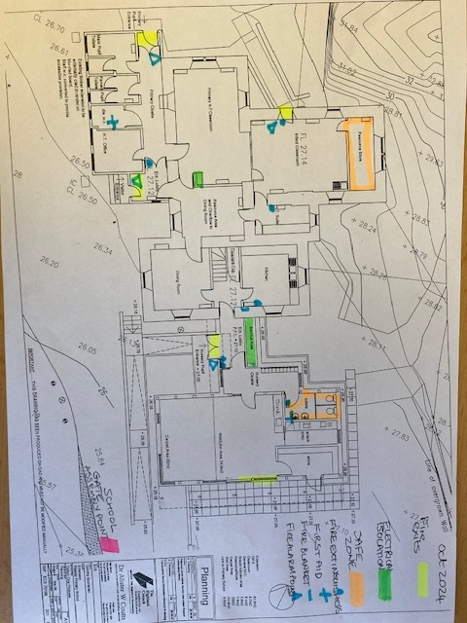

APPENDIX O: RECEPTION CENTRE
Raasay Community Hall
Isle of Raasay
IV40 8PB

Go out of School Park and turn right then turn right into Community Hall at sign.
Reception Centre
Name and Address

Access arrangements

Location of Key

External Key Holder(s)

Reception Centre
telephone no.
(Please note if one is
available to use)

School Office

Lock box at hall – code 1478

Raasay Community Stores 28 Inverarish, Raasay

RAASAY MAP/AERIAL FOOTAGE/SCHOOL LAYOUT

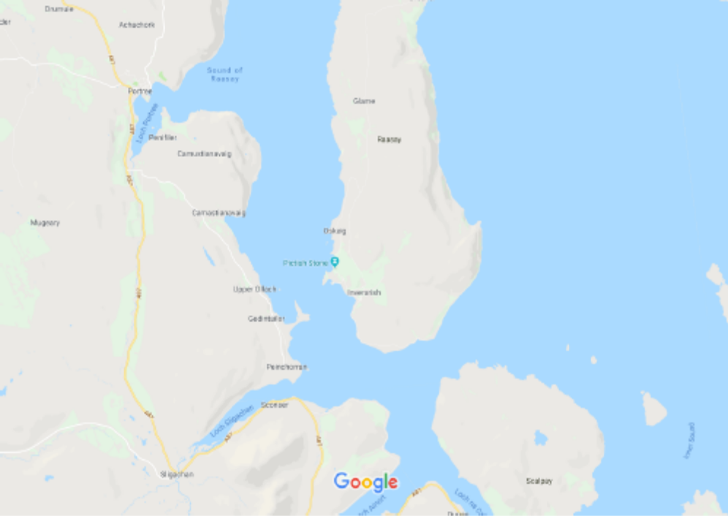

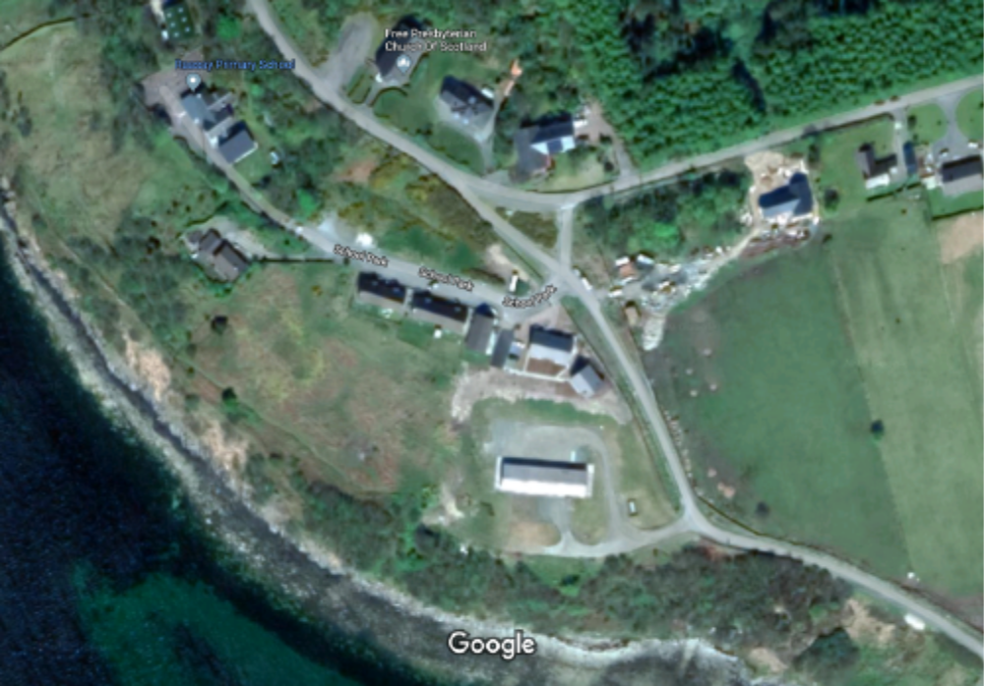
Raasay Primary School
Designated Reception Centre
(Raasay Community Hall)

Water isolation point

