Raasay Primary School
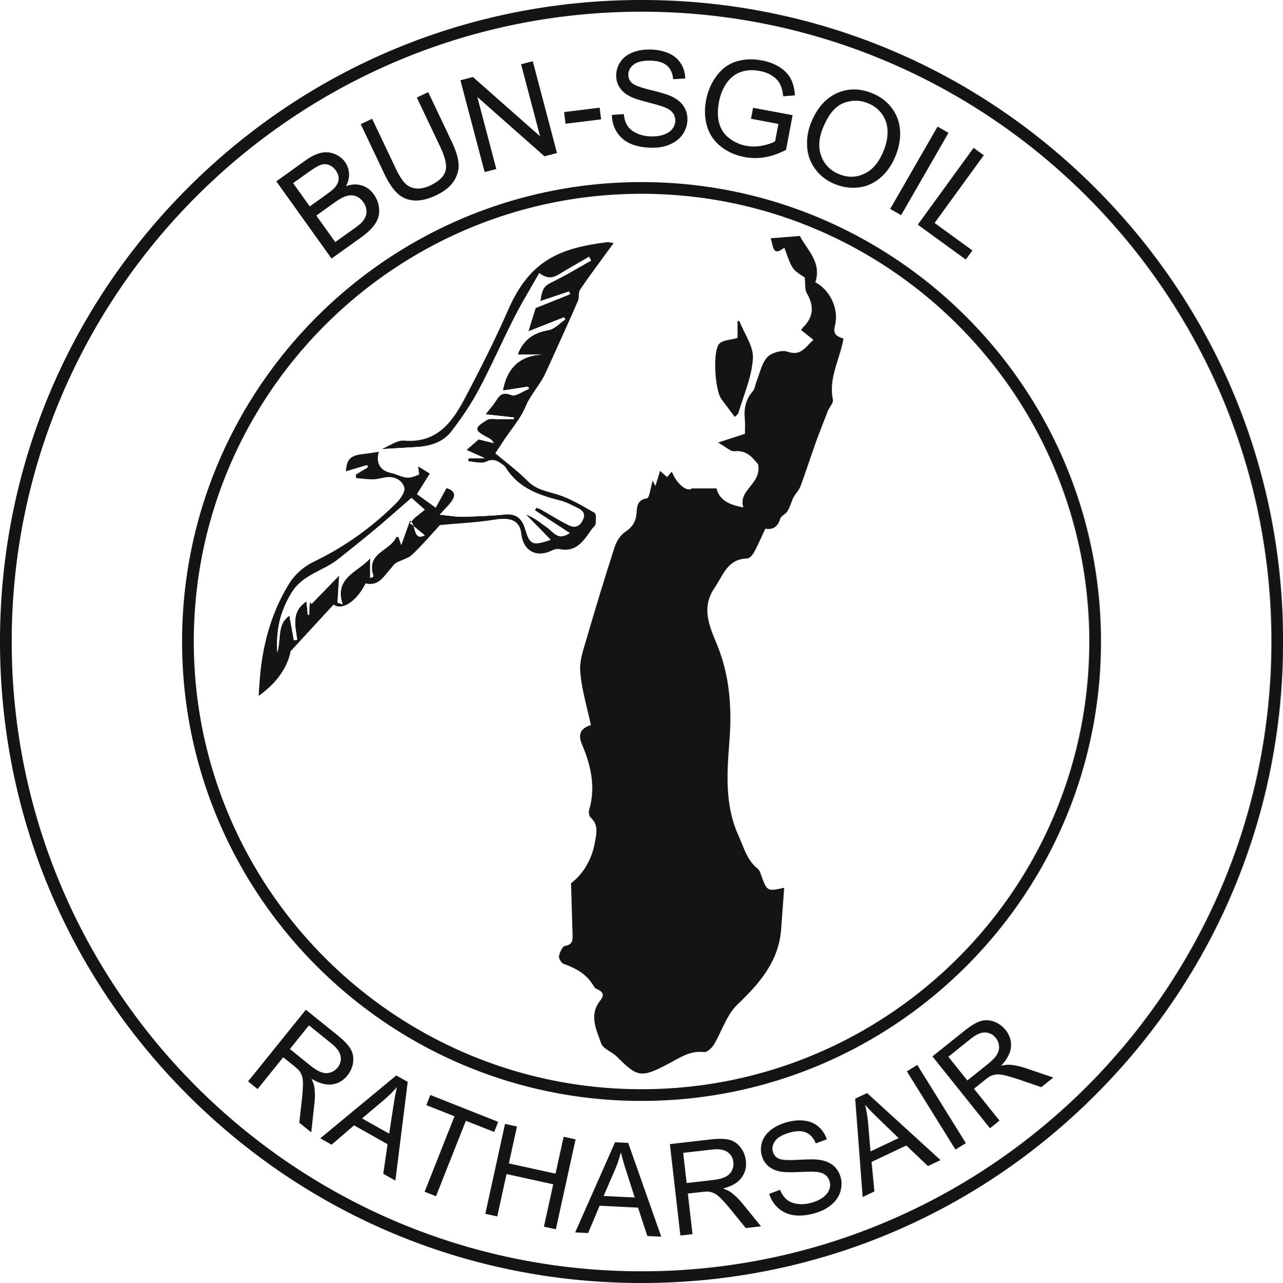
Administration of Medication in School

In Raasay Primary School, we encourage parents, when possible, to administer any medicine that cannot be taken outwith school hours and arrangements are made on an individual basis.
In accordance with the Highland Council and NHS Highland, the school has a policy on the administration of medication which we must review and follow. The full policy is available upon request but, in summary, states:
The principle adopted by prescribers will be that medicines should be taken outwith school hours. Where the Head Teacher agrees to the administration of medication within the school, this must be undertaken in accordance with safe and secure storage and administration of medicines in schools. Administration of medications shall only be authorised where that medication must be administered during school hours. All medication stored in school will be stored securely and safely and any medication requiring special storage conditions such as refrigeration must also comply with storage requirement. Staff should complete and sign the record sheet for medication administered to individual pupils.

Non- prescribed medicines will not be administered by staff in schools under any circumstances.
For any medication required to be administered at school, written permission and instruction from parents must be provided by completing the Admin 1A form, available from the school office. It is the responsibility of parents/carers to ensure that medications provided are kept up to date.

August 2026
Wilma Duncan, Head Teacher

