RAASAY PRIMARY SCHOOL
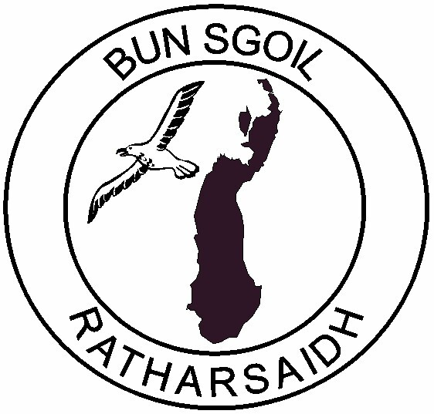
HOMEWORK POLICY

Research shows that homework does have a positive effect on learning. In Raasay Primary our Homework policy was reviewed and agreed that homework would be on a mainly responsive basis – to further support consolidation of learning. This policy is reviewed every three years.
“Where children were set homework, were encouraged by parents to do it and had it regularly marked in school, there was steady and consistent association between that and the level of performance.”
We recognise that, in its broadest sense, homework is any kind of learning which takes place out of school. However, for our purposes, we will consider homework to be:
- Work set by the teacher and completed at home in a given time.
- Work which reflects or develops class work and has clear outcomes.

Aims
Through setting homework we aim to:
- Encourage independence and good learning habits.
- Consolidate work taught in school and therefore raise attainment levels.
- Encourage and provide opportunities for parents to become involved in children’s learning.

In addition, homework will provide opportunities for:
- Assessing progress.
- Making use of a wider range of resources.
- Building pupil confidence by discussion of work with parents.
- Providing for parents a specific learning activity in which they can closely participate with their children.

Main Features of Homework Tasks
The content of the task set may vary from stage to stage and at different times throughout a session but should always be:
- Clearly understood by the pupil and closely related to ongoing class work.
- At an appropriate level of ability for the child.
- Able to be completed without specialised resources.
- Reflect a variety of activities although generally concentrating on basic skills.

Parents are encouraged to discuss homework tasks with class teachers should any problem arise.

At the early stages typical tasks will be:
- Discussion using pre-reading books
- Reinforcing new words
- Practising pages of reading
- Reinforcing sounds
- Practising writing
- Simple maths activities
- Finding out something or bringing in items for a class activity
- Spelling
- Choice reader and accompanying activities

At the Middle Stages typical tasks will be:
- Reading practice
- Spelling
- Maths e.g. tables, telling time/responsive tasks
- Research e.g. gathering information for a class project

At the Upper Stages typical tasks will be:
- A variety of follow-up work in all curricular areas, including topic related and current affairs research, book reviews, spelling, preparation for an individual presentation, reading and classroom responsive tasks.

Spelling – at all stages we use a variety of Highland Literacy Project methods.

Reading – a record of reading is within the Homework Dairy.
Homework Dairies are provided for all pupils.

Frequency and Length of Task
We are conscious of the fact that many children are involved in activities in the evening which are valuable to their education and overall development and well-being. Therefore, you should find that homework set should take no longer to complete than about 20 minutes with some exceptions for Upper Stages. We understand that, occasionally, some circumstances may make it impossible for work to be done at specific times and our weekly homework timetable allows for flexibility. However, please inform the teacher if you child has not managed to do his/her homework.

How Can Parents Support Our Homework Policy
- By ensuring homework is done while your child is alert
- By trying to provide a calm atmosphere with as few distractions as possible
- By discussing the work with your child and working along with him/her, especially at the Early Stages
- By checking that the quality and presentation is of an acceptable standard
- By discussing any problems arising from homework with the teacher through the homework diary or by phoning the school.

The role of parents regarding homework is greatly valued by the school and staff and provides a cohesive and coherent approach to learning.

