
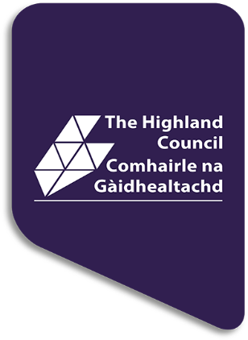

STANDARDS AND QUALITY REPORT 2025-26 AITHISG INBHEAN IS CÀILEACHD

Raasay
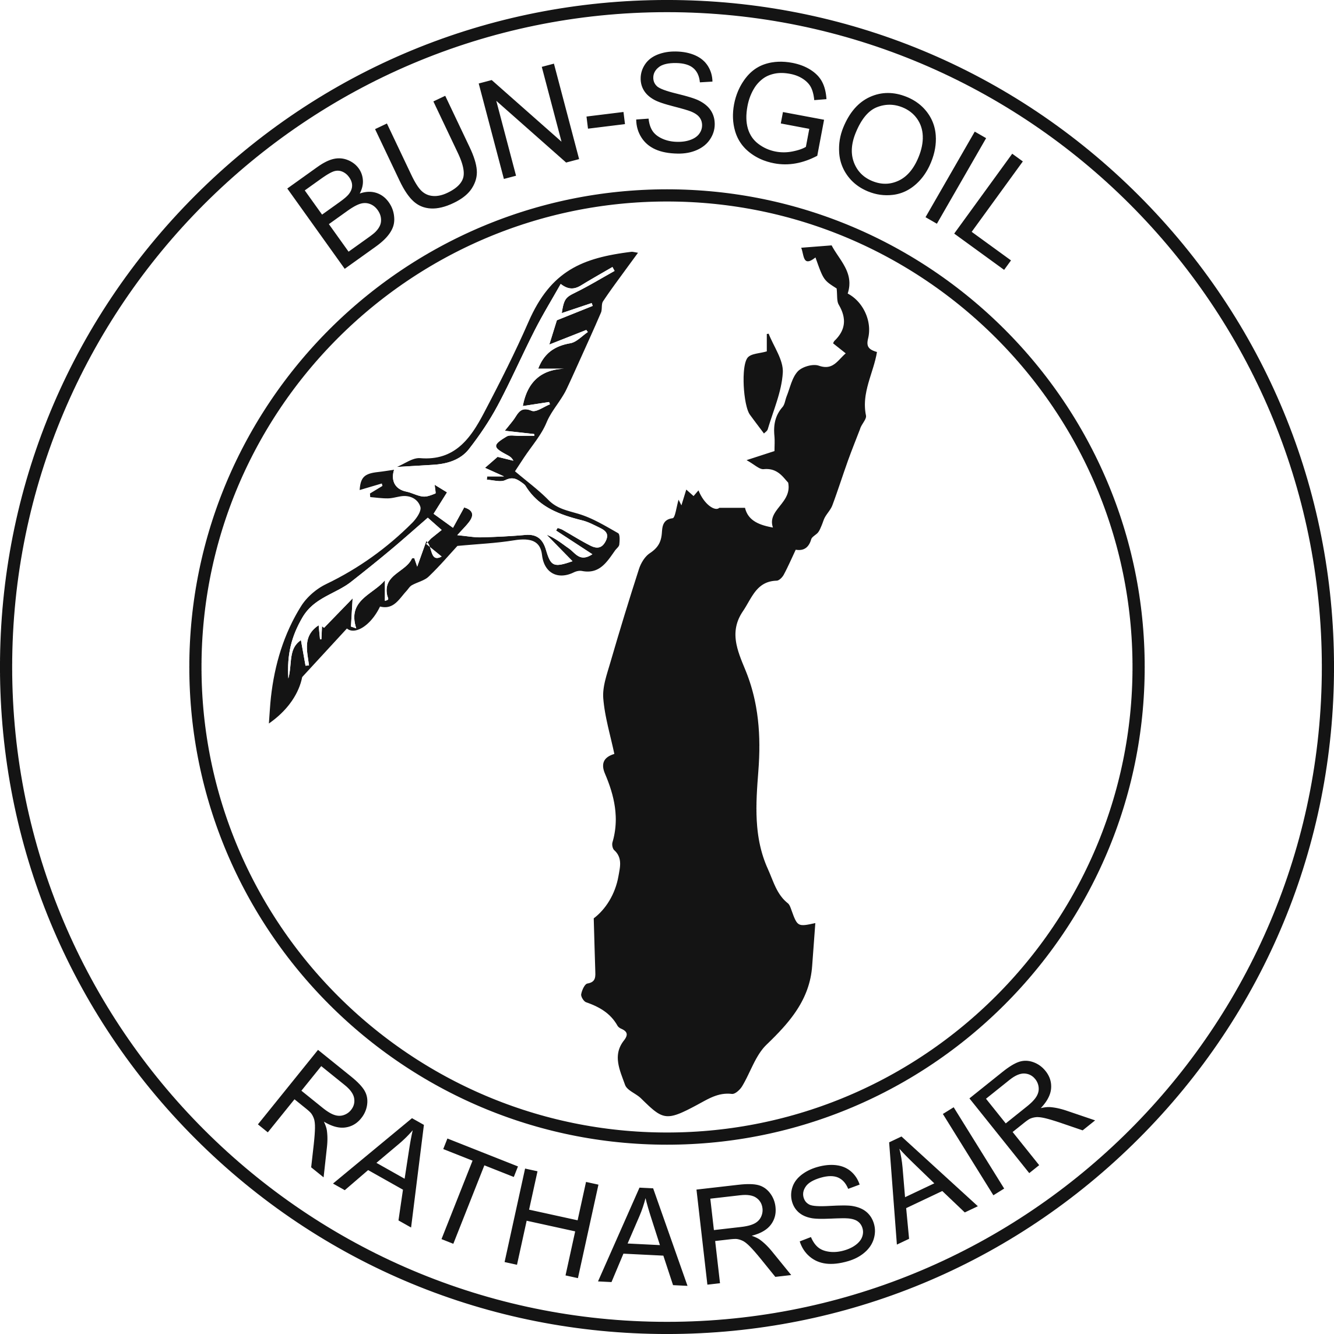
PRIMARY/ELC


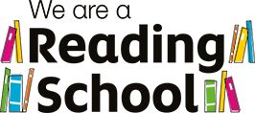
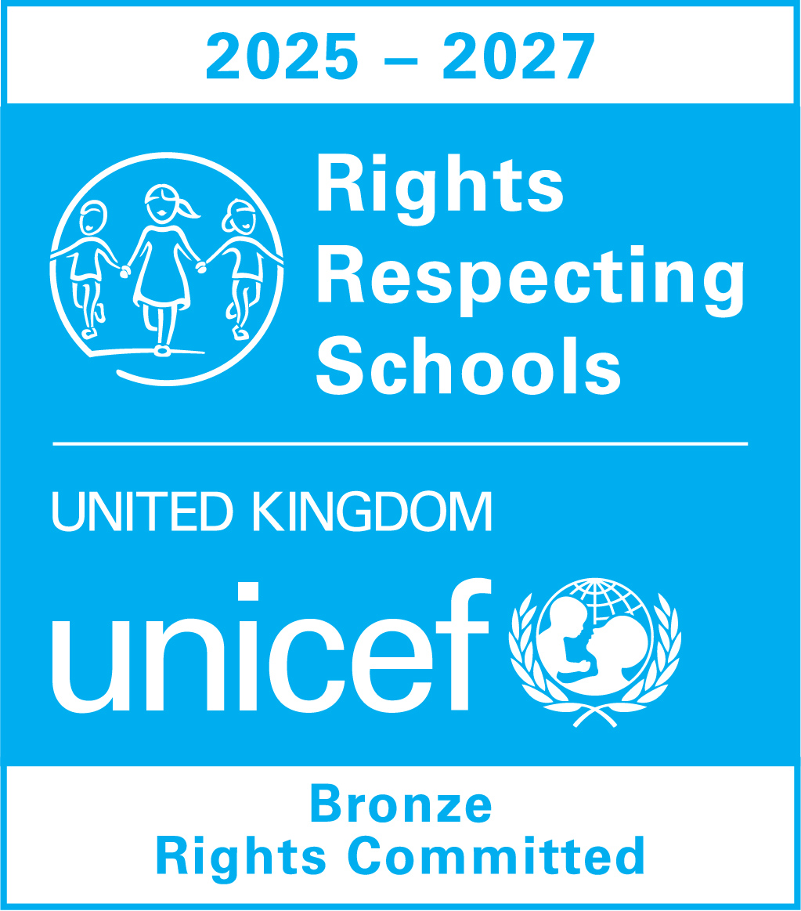


In this report the following words are used to describe the numbers and proportions used:
All | Almost all | Most | Majority | Less than half | Few
100% | Over 91% | 75% - 90% | 50% - 74% | 15% - 49% | Up to 15%

School Profile
Pròifil na Sgoile

The following information can be found on Parentzone Scotland. It is important to remember that statistical data alone is not a measure of how well we are doing. All schools are unique. To understand how well we are doing it is important for us to look at a range of different data sources.

Attendance  97% |  | Average Class Size  3 |  | Meeting PE Target  Target Met
Pupil Numbers (inc nursery)  7 |  | Teacher Numbers  1.5 |  | Pupil Teacher Ratio  3:1

2024/25 Proportions of pupils achieving Curriculum for Excellence Levels (P1, P4, P7 combined):
Reading |  | Writing |  | Listening and talking |  | Numeracy
All |  | All |  | All |  | All

We have had no exclusions this year.

Raasay Primary School is located in a rural, coastal setting serving the local community of Raasay on the Isle of Raasay.

There are 3 children attending the school and 4 children in nursery, ranging from N3 - P7. P1 - 7 are taught together in a single multi-stage class and there is a separate nursery for 3 and 4 year olds.

The headteacher has overall leadership responsibility for Raasay Primary School and has a teaching commitment.

As the school roll comprises a small number of children, attainment and progress will be expressed in ‘overall’ statements, rather than specific year groups or Curriculum for Excellence levels. This is to ensure the identity of individuals is not disclosed.

Overall, attainment across the school in literacy and English and numeracy and mathematics is very good. Children achieve appropriate CfE levels in literacy and numeracy and, across the school, a few children are exceeding nationally expected levels. All children who face barriers to learning are making very good progress towards meeting their individual targets.

Overall children are making the following progress:
Reading |  | Writing |  | Listening and talking |  | Numeracy
Very good progress |  | Very good progress |  | Very good progress |  | Very good progress

We have had no exclusions this year.

School vision, values and aims
Lèirsinn, luachan agus amasan na sgoile

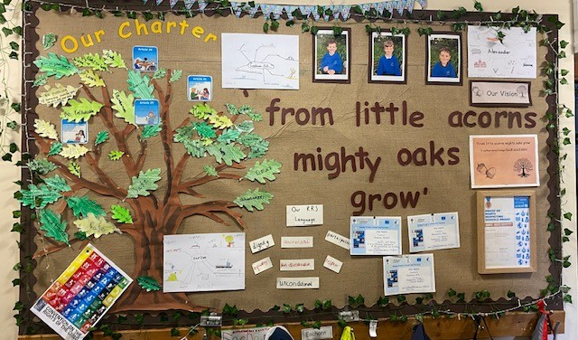
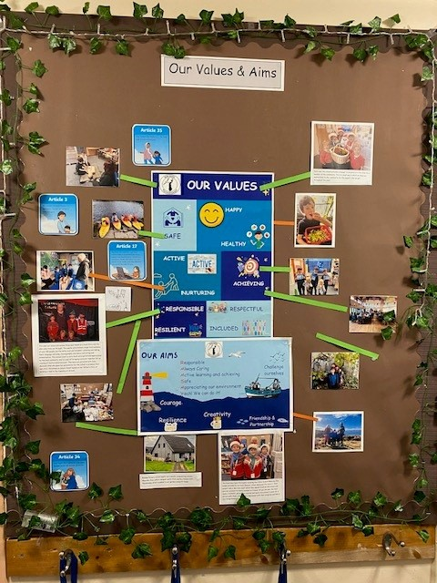

Review of progress for session
Ath-sgrùdadh air adhartas airson an t-seisein

These projects are linked to the vision and priorities for Scottish Education based on delivering excellence and equity. Parent/Carer information is available here.

School Priority 1: Add title
School Improvement Plan Priority 1 Reading for Enjoyment
Summary of progress | Next steps
- Improved attainment in Literacy across the school. Very good progress and achievement within Reading and Writing this session.  - A positive impact of this action is evidenced through PM Benchmarking Assessments and SOFA/SNSA Assessments, ACEL data  - Very positive feedback from Silver Level Accreditation meetings with Outreach Co-ordinator of Reading Schools with aim to achieve Silver by end of session 2026/2027  - All pupils have increased engagement in Reading for Pleasure across the school and have developed their own reading identities over the session because of the school’s actions to improve opportunities for Reading for Pleasure. This is evidenced through Learning Conversations, Self-Assessment, HGIOS Floor books and Pupil Voice and Pupil Choice through online ‘shopping’ for books of particular interest and genres.  - All pupils in the school and ELC have enjoyed opportunities to read for pleasure together. Sharing books at assemblies, reading stories to Freya our Thera Pet and through Book and a Biscuit session. All pupils have enjoyed having opportunities to share books with each other, read with other schools and nurseries and have visitors come in to read to them  - All nursery pupils have had the opportunities to take out the ‘Book Bus’ and to have community members read to them out at the local shop. This initiative has positive outcomes for our children and our community members, and they have detailed this to staff and parents.  - Strategies which have been successful in engaging children, staff, parents and the wider community include: close collegiate working between HT and Outreach Worker, All practitioners engaged on improving opportunities for Reading for Enjoyment for continued positive impact learner’s attainment across the setting, Staff collaboration to a continued commitment and development of the Reading Schools Journey through various initiatives, and partnerships within the school, parents, community and others settings within the ASG and out with.  - All pupils have been involved in developing their school library and have access to learner-led reading shelves and personal reading shelve  - All pupils have had the opportunity to have reading sessions outdoors when possible and incorporate reading into school events eg: Christmas Show and Prizegiving. Also, opportunities to read in Gaelic and share their reading skills within the Mod winning the Oban Rose bowl - English Medium School with the most Gaelic points  - All pupils engage in celebrating reading development through certificates and Assemblies.  - All parents are supportive of the project and informed of where we are at through Parent Council Meetings  - The Community know that this is one of our Improvement Priorities through sharing during community events eg: Prizegiving  Examples:  - All staff use the Scottish Book Trust resources to support the use of contemporary literature within the classroom and ELC  - Our school Reading Journey is visible throughout the school library and ELC setting, and this allows for all adults to engage in conversations with children regarding their reading interests and reading identities.  - Collegiate working with other settings on the Reading Schools Journey within the ASG and other very small settings to share our reading interests and recommend authors and titles.  - There continues to be a shared understand and shared work between school staff and ELC in continuing to develop and a Reading Culture within the School  - Practitioners are able to use data effectively to identify the needs of their learners and improve learning, teaching and assessment in Reading.  - All Parents are supportive of our Reading Schools Programme and value the positive impact it has had on their children literacy and well-being.  - Community members and parents of pre-nursery have supported our Reading Schools Silver journey by being invited in to read with the pupils or reading to the toddlers in our community. | - Gold Level – Reading Schools to be achieved by June 2027  - ELC and school staff to continue to engage in Scottish Book Trust Reading Schools Accreditation (Gold) training and information sessions next session to continue to widen knowledge around Reading for Pleasure.  - Nursery/School self-evaluation, WTA Collegiate Calendar, Quality Assurance Calendars, termly overviews, Assessment Calendars, Parental Engagement Calendar and Tracking, Monitoring and Reporting Calendars in place to support Reading Schools Year 3 (Gold) in session 2026/27  - Pupil Feedback Surveys to inform next steps  - Staff Feedback Surveys to inform next steps  - Parental Feedback Surveys to inform next steps  - PM Reading Assessments  - Blackwell Spelling Assessments  - Writing Rubrics/Assessments  - 100% of staff will model reading by reading their own choices in class and reading class novels/texts  - All staff to research (during CPD) contemporary children’s titles  - Cross-working between all ELC and School staff  - All staff to continue to engage with partner settings in the ASG and Eigg/Muck Primaries and Nurseries.  - All staff to continue to recommend and research with pupils relevant reading materials to meet the needs/interests and lives of our pupils.  - All staff to complete Reading Schools Attitude Surveys and Impact Surveys  - All Staff will have input into Gold Action Plan  - All Staff to have input into initiatives to share the importance of our Action Plan with the community on Raasay and on Skye eg: Radio Skye, School Website, Vlogs/Blogs  - All pupils involved in creating a Gold Action Plan  - All pupils to meet termly and implement plans  - All pupils to wear ‘Ask me what I’m reading badges’  - All pupils to share book reviews/recommendations at Assemblies, across the ASG and partner schools eg: Egg/Muck  - Older pupils to be reading mentors for new P1s  - Older pupils to continue to incorporate reading into Christmas Show/Prize-Giving, WBD and in Gaelic at the Local Mod  - Older pupils to select books of interest from online for personal and IDL reading  - All pupils to continue to have access to the local library and the library van  - All pupils to continue to hear stories read by local community members  - Continue ‘Book and a Biscuit’ initiative  - Older pupils to write reviews for website  - Watch ‘Authors Live’  - All pupils to engage in Reading picnics  - Pupils and staff to continue to engage families and the community about our Reading progress – during PC Meetings/Open Afternoons and Prize-givings and other events as they arise.  - Continue to include and support Reading for Pleasure in home learning  - Continue to receive prize-books tailored to pupil interests as prizes at the end of term prize-giving.  - All pupils to take part in impact survey.
Impact
- 100% of pupils are in the Reading Leadership Group and met termly through Pupil Council Meetings to discuss and implement plans.
- 100% of pupils detail the positive impact of Reading Schools within Reading Schools Learner Attitude Survey
- 100% of school pupils have worked closely with other schools in the ASG to collaborate and share their Reading Schools journey.
- 100% of school pupils have worked with other small schools of similar size to share their Reading Schools journey – this has created opportunities to share reading recommendations across settings and increase confidence and enjoyment of Reading.
- 100% of school pupils have improved attainment in Reading and Writing through Reading PM Benchmarking Assessments and SOFA/SNSA Assessments, ACEL data
- 100% identified Actions which included them setting up their own After School Reading Club.
- 100% of our pupils are committed to developing their skills and knowledge of a variety of genres through D.E.A.R sessions, IDL and value opportunities to Read for Pleasure.
- 100% of pupils have improved attainment in Literacy across the school. Very good progress and achievement within Reading and Writing this session.
- Empowered staff and developed leadership to improve overall capacity of the school
- There is a strong focus on improving Reading for Enjoyment for our pupils within the setting
- Range of strategies and initiatives in place to support children to take responsibility for their own reading journey eg: personal library walls and log of books read
- Planning of learning, teaching and assessment of Reading is proportionate and manageable.
- Pupil/Staff/Parent Surveys show impact.
- Very good progress was made in this area.

School Priority 2: Add title
School Improvement Plan Priority 2 UNCRC Rights Respecting Schools Silver (August 2026/Gold June 2027)
Summary of progress | Next steps
- Improved knowledge and understanding of key articles in the Convention of the Rights of the Child and that Human Rights and the needs of every child and young person are at the centre of Education  - The Rights permeate through our HWB curriculum including Relationships and Behaviour  - All parents are supportive of the project and informed of where we are at through Parent Council Meetings  - The Community know that this is one of our Improvement Priorities through sharing during community events eg: Prizegiving and support local and global campaigns. Eg: We adopted a beach helped us to clean it with support from Skye Business, Mowi who provided boats, bags, gloves and litter pickers.  - Pupils have written to Mowi to ask for their support with the campaign.  - Pupils informed the community of our campaign and asked for their help  - A positive impact of this action is evidenced through surveys, learning conversations, learner statements and Pupil Voice/Council.  - Very positive feedback from Rights Respecting Schools Assessor during HT collegiate meets to update her on progress.  - All pupils have increased engagement and understanding across the school of the UNCRC and have had a focus on 5 of these Rights across the year.  - There is a well-established Steering Group that forms part of our Pupil Council who lead the rights-respecting journey.  - Pupils have shared their plans with parents during Parent Council Meeting in August 2025 and introduced the ABCDE of Rights.  - HT has shared the Silver Journey with Parents during Parent Council Meetings and updated them on progress  - HT has been undertaken the RRS Silver Training and RRSA E-learning  - Rights have been explicitly taught through Health, Assemblies, IDL links and specific subject areas/charity work  - The School Charter has RRS at it’s heart and continues to be developed and evolve  - Pupils are taught and learn about rights through links with Eco Schools work, Sustainable Development Goals, Enterprise, Charity and Wider Achievement eg: Junior Dukes  - Pupils and Staff link rights to planning IDL and to Reading Schools Journey/Expressive Arts/Gaelic Language opportunities  - Pupils are taught and learn through rights School Charter, SHHANARRRI Values Chart, emotional check-ins, collaborating with other very small setting – Eigg/Muck classroom link, Safe, Strong and Free in Nursery and Active Schools opportunities.  - Pupils are all active members of our Pupil Council  - Pupils chose a local and global cause to support – adopting a beach and climbing Dun Caan Challenge for UNICEF (chosen charity)  - Pupils have all been accredited with Young Leaders Certificates in recognition of running an intergeneration Curling Event for the community as part of Article 31 and Article 24.  - All pupils have an active role in suggesting and supporting the delivery of after school clubs – Article 4, Article 12 and Article 31  - All children have had the opportunity to reflect on the impact of their actions through UNCRC Floor book and all have detailed the positive impact this has had on themselves as individuals, community members and the local community and wider world.  - All pupils have enjoyed the opportunity to have regular and meaningful choice in their learning through responsive planning eg: Greeks  - Strategies which have been successful in engaging children, staff, parents and the wider community include: collegiate working between HT and colleagues. All practitioners engaged on UNCRC. Staff collaboration to a continued commitment and development of the RR Schools Journey through various initiatives, and partnerships within the school, parents, community and others settings within the ASG and out with.  - All pupils have been involved in developing their classroom walls and corridors to highlight the rights.  - All pupils engage in reflecting on the journey.  - ELC pupils are encouraged to make Rights Real through SHHANARRRI reward chart, language of SHHANARRRI  - All pupils have had a focus this year on Article 4, Article 7, Article 12, Article 24, Article 30 with a specific focus on Article 31 across the ELC and School.  Examples:  - All staff use the SHHANARRRI Reward Chart, Emotional Check In, Charter, within the classroom and ELC and access the RRS Website  - Our school RRS journey and Charter is visible throughout the school and ELC setting,  - Collegiate working with other settings on the RRS journey.  - There continues to be a shared understanding and shared work between school staff and ELC in continuing to develop RRS across the setting  - Practitioners highlighted the 5 key articles this year through a variety of initiatives: assemblies, lessons, IDL, Health, Charity, the 4 context planner, RME, Social Enterprise, Gaelic Mod, Eco Flag (5^{th)} in February, Curriculum, Sustainability, Junior Dukes and Outdoor Learning, Kayaking, local and global campaigns and our Community Drama Production.  - All Parents are supportive of RRS plan and value the positive impact it has had on their children.  - Community members and parents of pre-nursery have supported RRS by supporting our initiatives throughout the year and participating where possible.  - We have made very good progress with this priority.  - Our school charter is visible throughout the school, and this allows for all adults to engage in conversations with children regarding their rights and their responsibilities.  - Children are becoming more familiar with the language of rights and have created displays to demonstrate this.  - All children participate in charity work – Blythswood, Save the Children, Comic Relief.  - The creation of Fun 31 Wall | - August 2026 – Silver Accreditation Meeting with Assessor  - Gold Level –Rights Respecting Schools to be achieved by June 2027  - Carry out surveys and audits  - Open afternoons  - Review measures in Action Plan Termly  - ELC and school staff continue to access UNCRC resources to support CPD.  - Nursery/School self-evaluation, WTA Collegiate Calendar, Quality Assurance Calendars, termly overviews, Assessment Calendars, Parental Engagement Calendar and Tracking, Monitoring and Reporting Calendars in place to support Rights Respecting Schools Year 3 (Gold) in session 2026/27  - Staff Meetings to share priority and termly planning meetings to agree the actions for the term.  - Weekly pupil/staff meetings with a focus on each area of the strand in Measures section on SIP  - Pupil Feedback Surveys to inform next steps  - Staff Feedback Surveys to inform next steps  - Parental Feedback Surveys to inform next steps  - 100% of staff will model language of rights.  - Most children will know and understand the concept of Duty Bearers and Rights Holders.  - Most children will understand the concepts of fairness and equity  - Pupil led Governance – local rights based advocacy – eg: rural transport - community led campaigns “demanding rights”  - All staff to attend CLPL sessions and engage in research on UNCRC Gold  - Cross-working between all ELC and School staff  - All staff to continue to engage with partner settings in the ASG and Eigg/Muck Primaries and Nurseries.  - All Staff will have input into Gold Action Plan  - All Staff to have input into initiatives to share the importance of our Action Plan with the community on Raasay and on Skye eg: Radio Skye, School Website, Vlogs/Blogs  - HT to create a School UNCRC Calendar – develop a range of activities/campaigns/events and map out for the year – link with Assemblies/Open Afternoons/PC Meetings/information sharing with parents and the wider community.  - All pupils involved in creating a Gold Action Plan  - All pupils to meet termly and implement plans  - Meetings/Open Afternoons and Prize-giving and other events as they arise.  - Continue to include and support RRS in home learning and wider achievement eg: Junior Dukes  - Continue to develop Display areas across the School and ELC
Impact
- 100% of pupils are in the RRS Leadership Group and met termly through Pupil Council Meetings to discuss and implement plans.
- 100% of pupils detail the positive impact of RRS and can talk about and explain five of the rights and how they link to their own lives.
- 100% of pupils in nursery understand, enjoy and participate in learning about importance of being Safe, Happy, Healthy (Article 12,24 and had a focus on Article 31 this year – Play and reset opportunities in the nursery and culture/arts in our School Production Calum’s Road
- 100% of pupils can explain the concept of rights being universal and unconditional
- 100% of pupils are able to give at least 2 reasons why some children can not access rights.
- 100% of parents have a basic understanding of CRC and know at least one right and the terms universal and unconditional.
- Most members of the community who engage with the school know that UNCRC is a school priority.
- All children are able to use the language of rights within the class and playground
- 100% of pupils and staff can consistently use UNCRC language when referring to the Charter and the VVA of the school and ELC.
- 100% of pupils are able to identify the rights they have within the school environment and how they are supported within the school eg: the right to play
- All pupils have had the opportunity to have pupil voices within curriculum areas and pupil council meetings and across settings.
- 100% of teaching staff and ELC staff have planned for pupil voice once a term in curricular areas.
- 100% of school pupils have worked with other small schools of similar size to share their RRS journey and campaigns.
- 100% identified Actions which included pupils setting up their own After School Reading Club through pupil voice and Pupil Council Meetings.
- 100% of our pupils are committed to the UNCRC rights through campaigns
- P6 Pupil has shared with parents information on CRC during PC meeting
- All pupils have had input to and evaluated the 5 HIGIOUS Themes
- All pupils have self-assessed their well-being using the Well-being Wheels
- All pupils have shared their views through learning conversations, surveys, online surveys, self-evaluation forms and exercised their pupil voice through meetings and learners’ statements
- ELC staff have developed block play within the ELC setting – Article 31
- All staff have linked UNCRC Articles to IDL, Project work, 4 contexts of learning, personal achievement where possible, Ethos and Life of the school and curriculum areas.
- All staff have linked the 5 Articles to Active Schools Leadership opportunities, Junior Dukes, HWB Curriculum, Mod and Expressive Arts/Gaelic language.
- All ELC Staff have had regular meetings with Small Schools Group and North Schools Group to support professional development in Play/Floorbooks
- All staff are able to use the language of rights and are familiar with the UNCRC Articles.
- Very good progress was made in this area.
- Pupil/Staff/Parent Surveys show impact.

Wider achievements
Coileanaidhean nas fharsainge
UNCRC – Silver ‘Rights Aware’ Dun Caan – We climbed Dun Caan as part of our Global Campaign to raise awareness of the work of UNICEF throughout the world. We wanted to Highlight their work from the highest point on
Raasay.
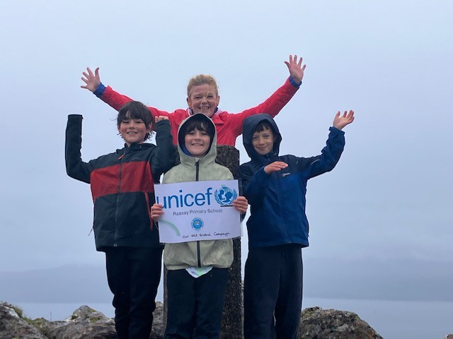

Ice Skating Article 31 – We had the opportunity to go to Skye to learn a new skill. We had never ice skated before and we gained confidence over the skating session – we now hope to do this again next year.
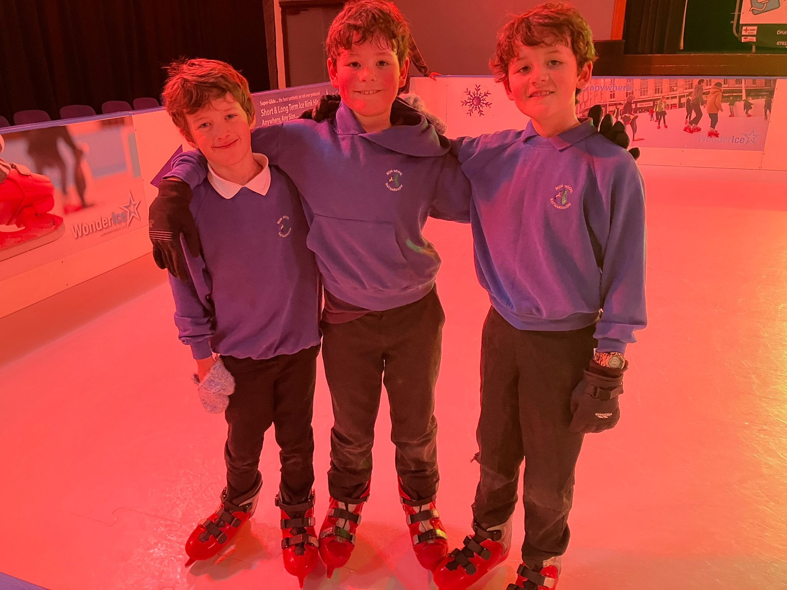
Reading Schools Article 15 – We decided during our Pupil Council meeting that we would like to set up and run an After School Reading Club. We have enjoyed it so much we are going to run it again next session.
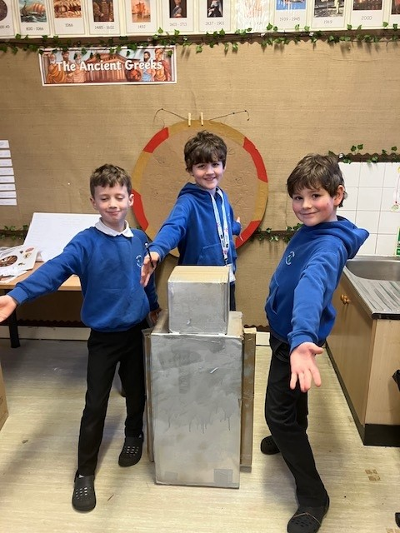

Walk to School Week – Article 24 – For the fourth year in a row, we have come top in the UK Small Schools for the Big Walk and Wheel with a final result of 100%.
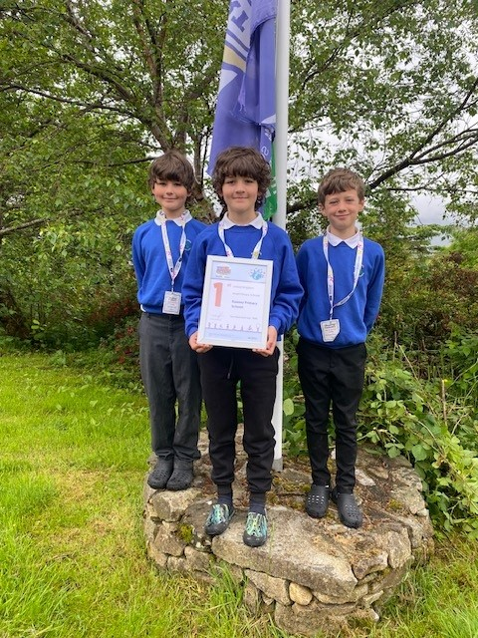
Visit to Skye Alpacas – Article 24 & 31 -We went on a whole school trip (staff and pupils) to Skye Alpacas as part of H&W for all in our setting.
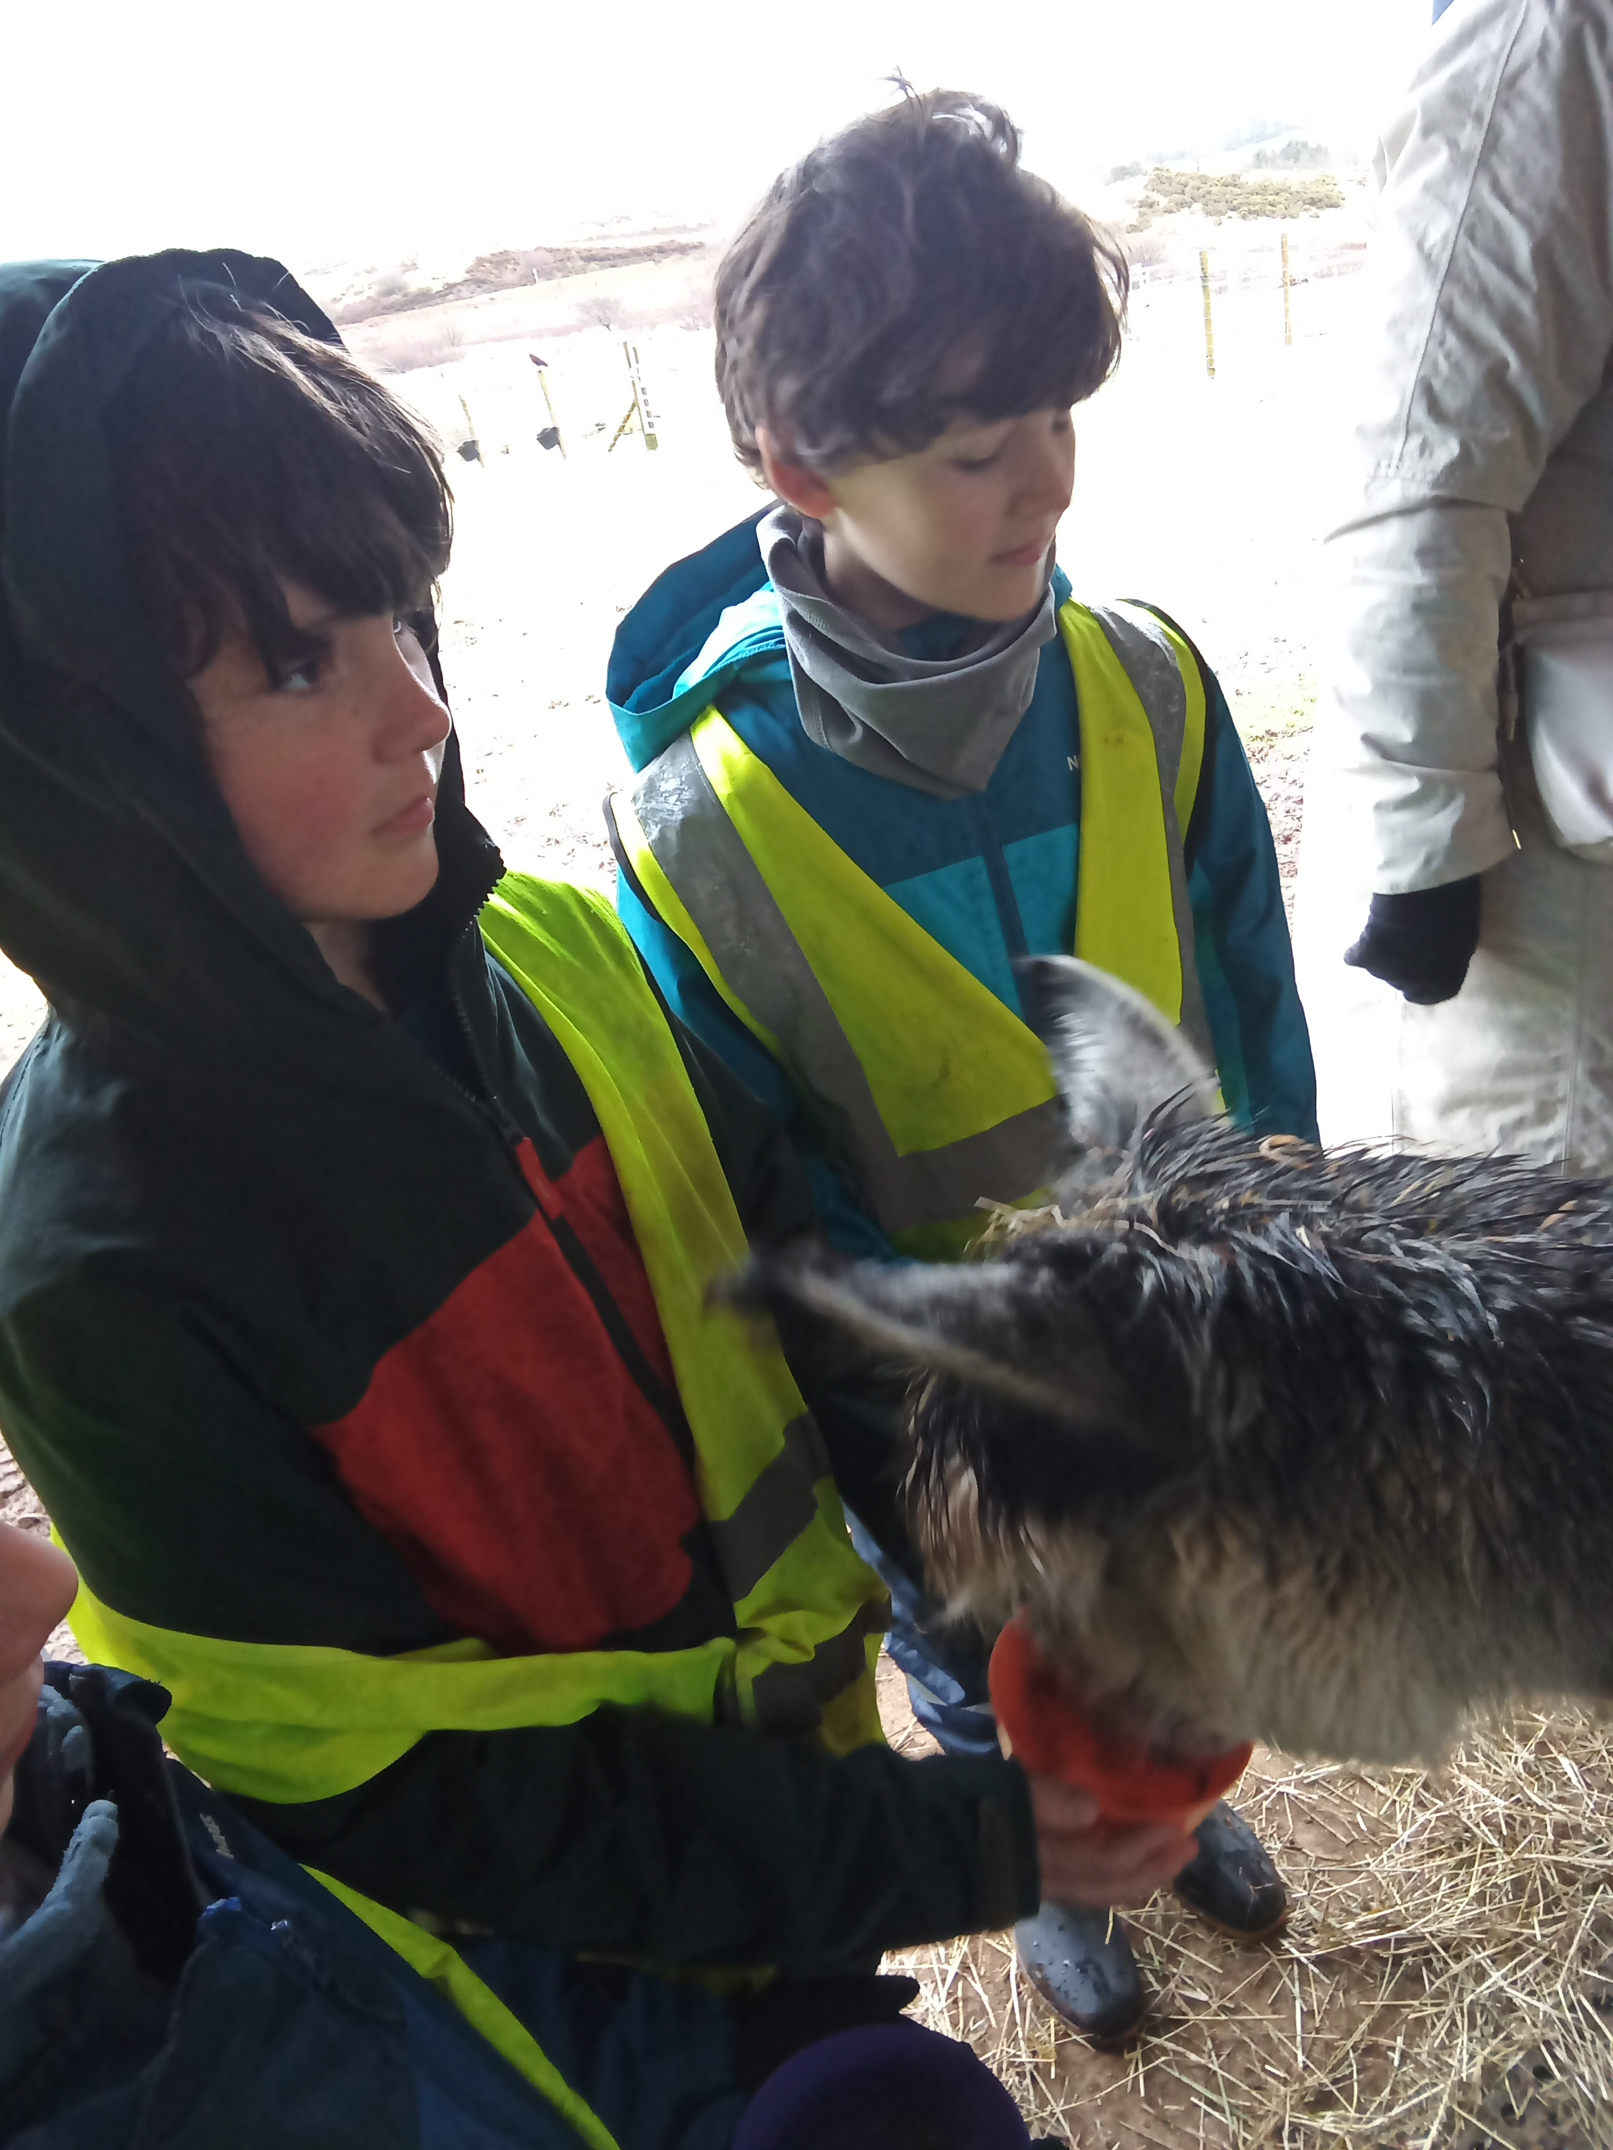
Fifth Green Flag – Article 24 Article 4 – We were all so delighted to achieve our fifth Green flag which recognises all the Eco initiatives and ongoing work we do in promoting sustainability in our school and community.
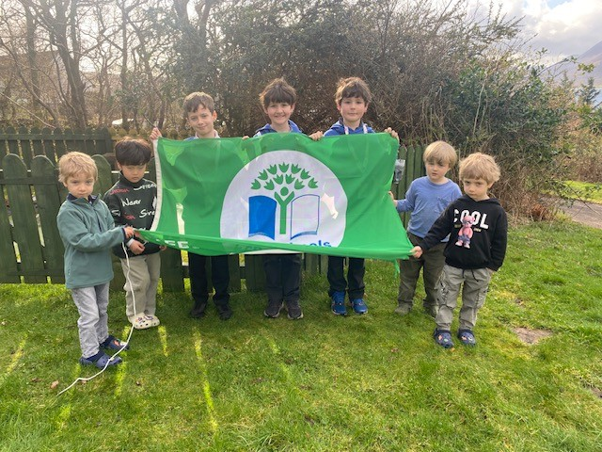
Curling/Enterprise/Rights Respecting Schools Article 31/Article 24 – Pupils organised and ran an indoor curling event for the Raasay community. This was to promote H&W opportunities for people of all ages in Raasay and was part of an ACORNS enterprise fundraising event.
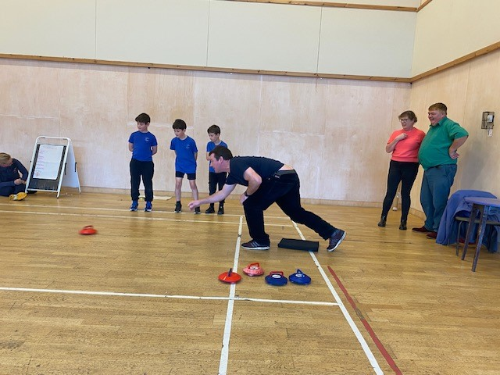
Community Lunch – Article 24 – We regularly support the local community lunch by serving at the event and engaging with the local community. We also love wearing our ACORNS aprons!
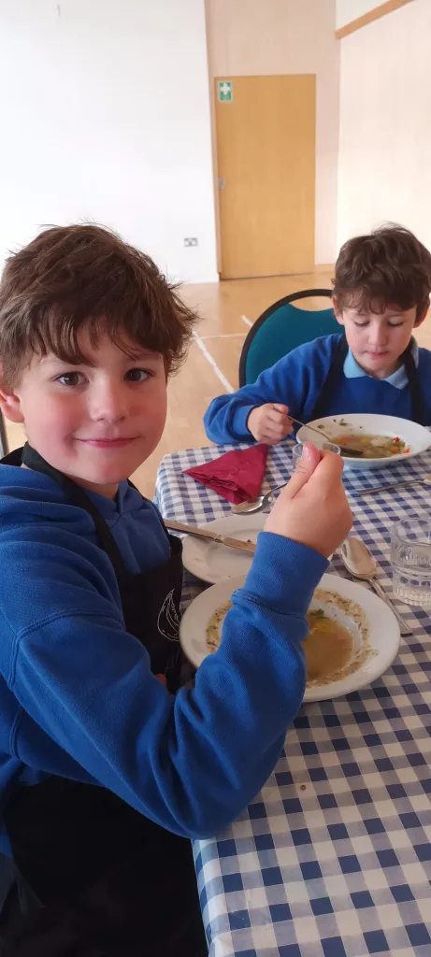
Mod – Article 30 – For the 8th year in a row we have won the Oban Rose bowl in recognition of being the English Medium school with the most Gaelic points at our local Mod.
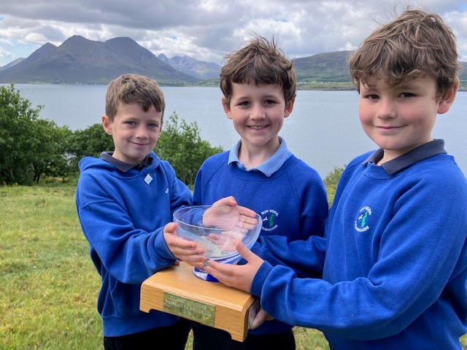

Weaving Club – Article 15, article 31 – We have continued to develop our Weaving skills and have learnt new techniques in our weekly After School Club with Lillian.
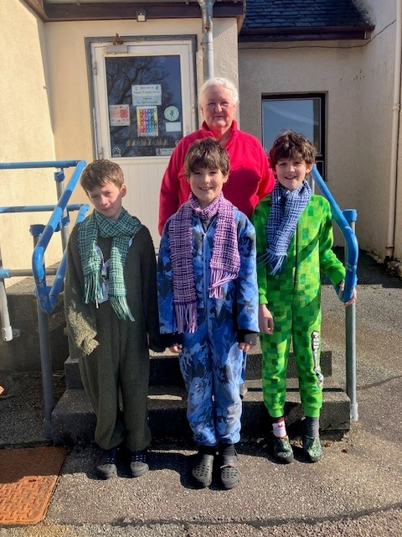
Xmas Jumper Day for Save the Children – Article 4 & 27 – As the rights of the child sit at the heart of our school ethos, we fundraise for the charity Save the Children by wearing our Christmas jumpers for the last week of term 3.
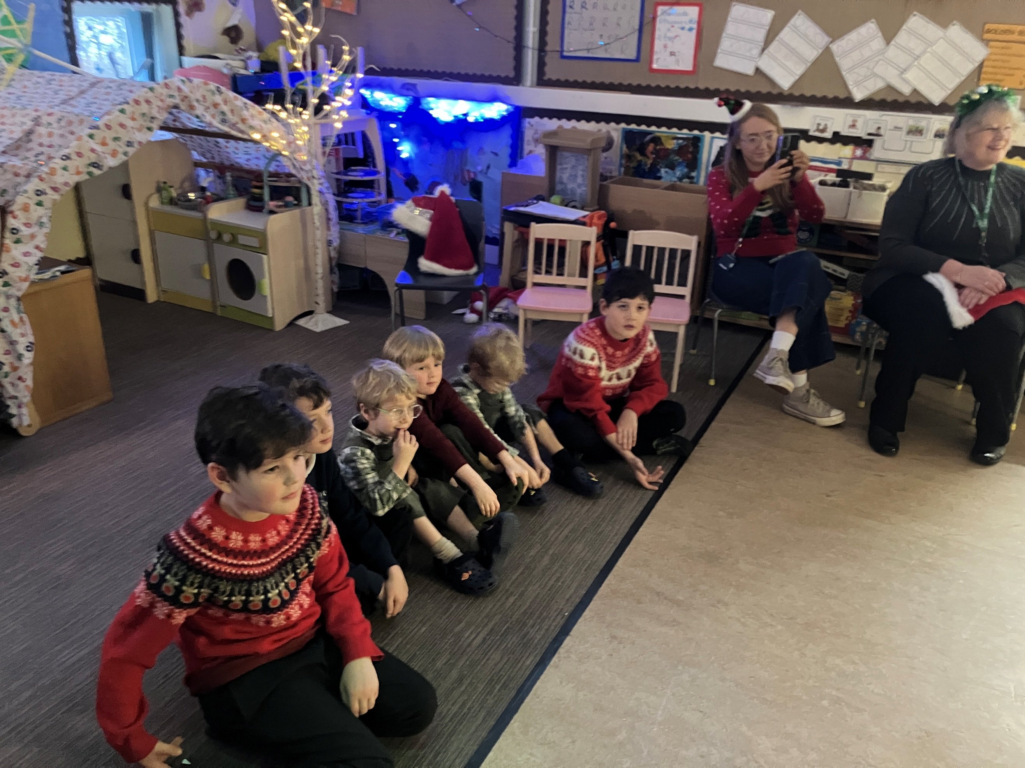
Junior Dukes – Article 24, 29 & 31 – As part of wider achievement, pupils have undertaken the Junior Dukes award and have successfully achieved their accreditation for this session. They will now move on to the next level next session.
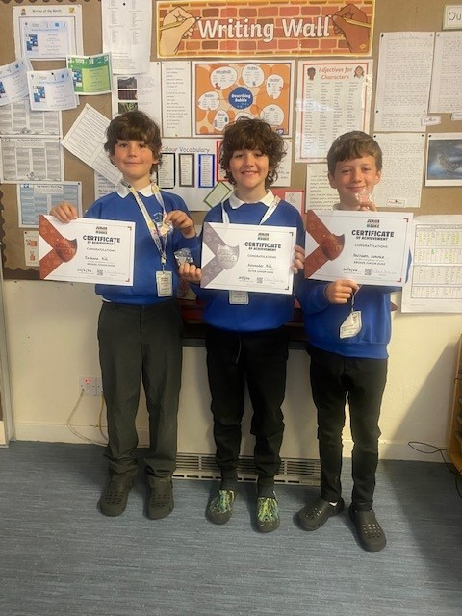

Blythswood Charity Shoebox Appeal – Articles 4, 38 – Each year, we work with the community to resource and fill shoeboxes for the Blythswood Shoebox Appeal. This year we filled 11 boxes to send off.
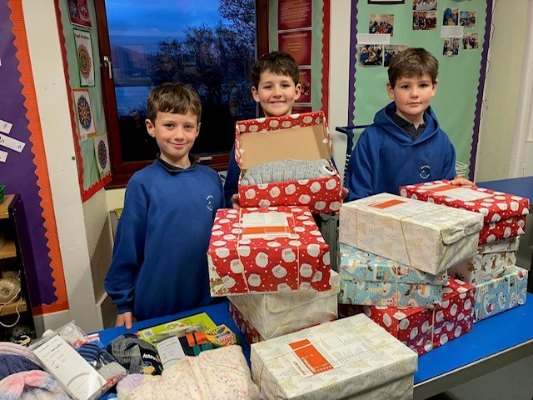
Easter Egg Hunt – Article 31 – Our local Community Council is a supportive partner throughout the year and they organised an Easter Egg event for us at the Walled Garden.
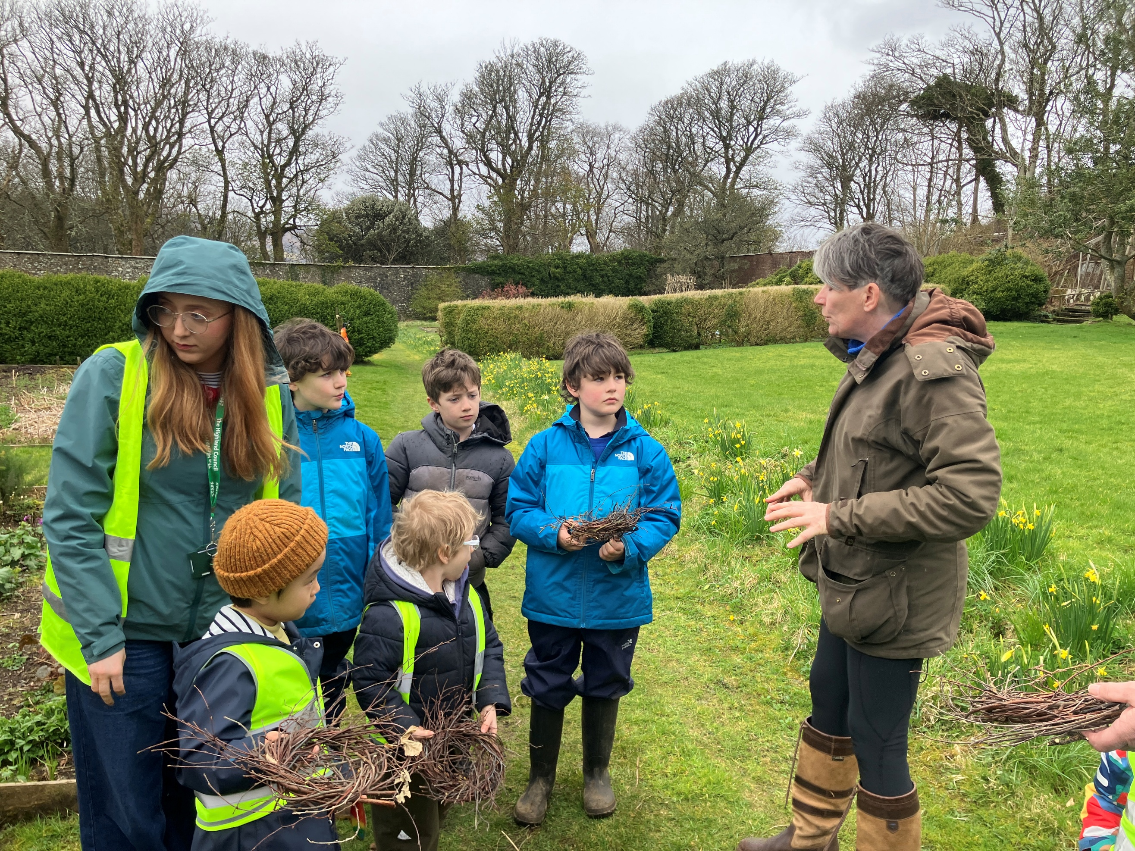
Christmas Show – Articles 12, 29, 30, 31 – Our P6 pupil came up with the idea of a Christmas production based on the story of Calum’s Road. Our performance celebrated the culture, language, history and religion of our island and we worked in partnership with skilled, local individuals who supported our production.
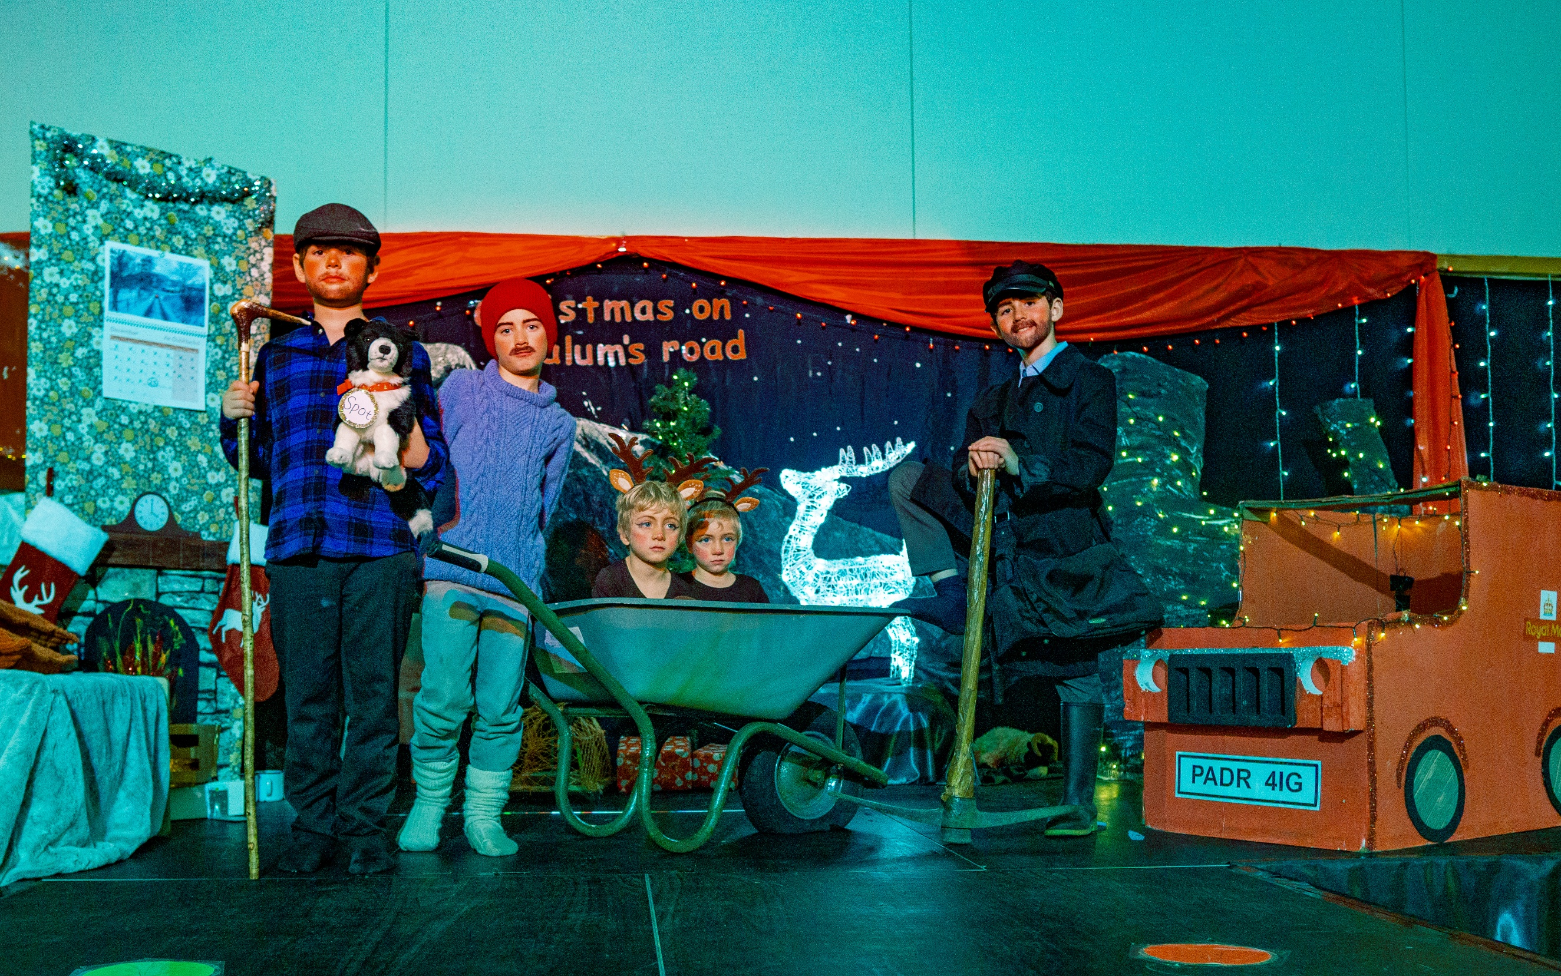

Art workshop exploring dreams and storytelling with Mexican Artist Daniel Gomes – Article 31

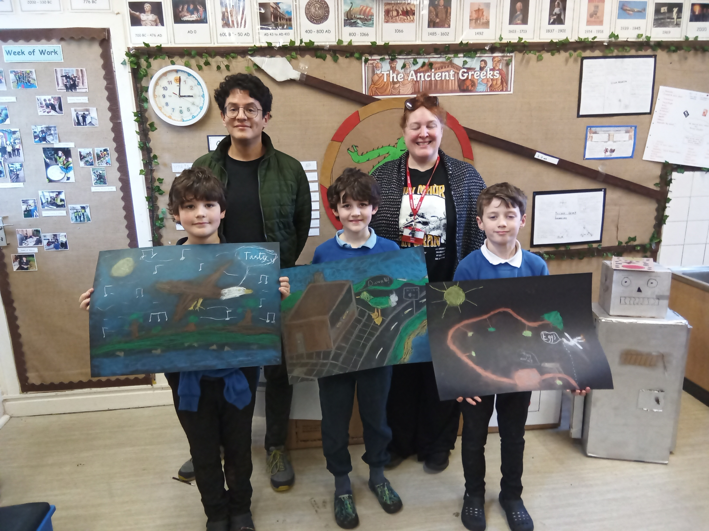
Reading Schools visit to MacDiarmid School Article 29 & 12 – As part of our Reading Schools Silver journey, we visited MacDiarmid Primary School to share with them our journey so far and we were acting as Reading Ambassadors to support them on their journey.
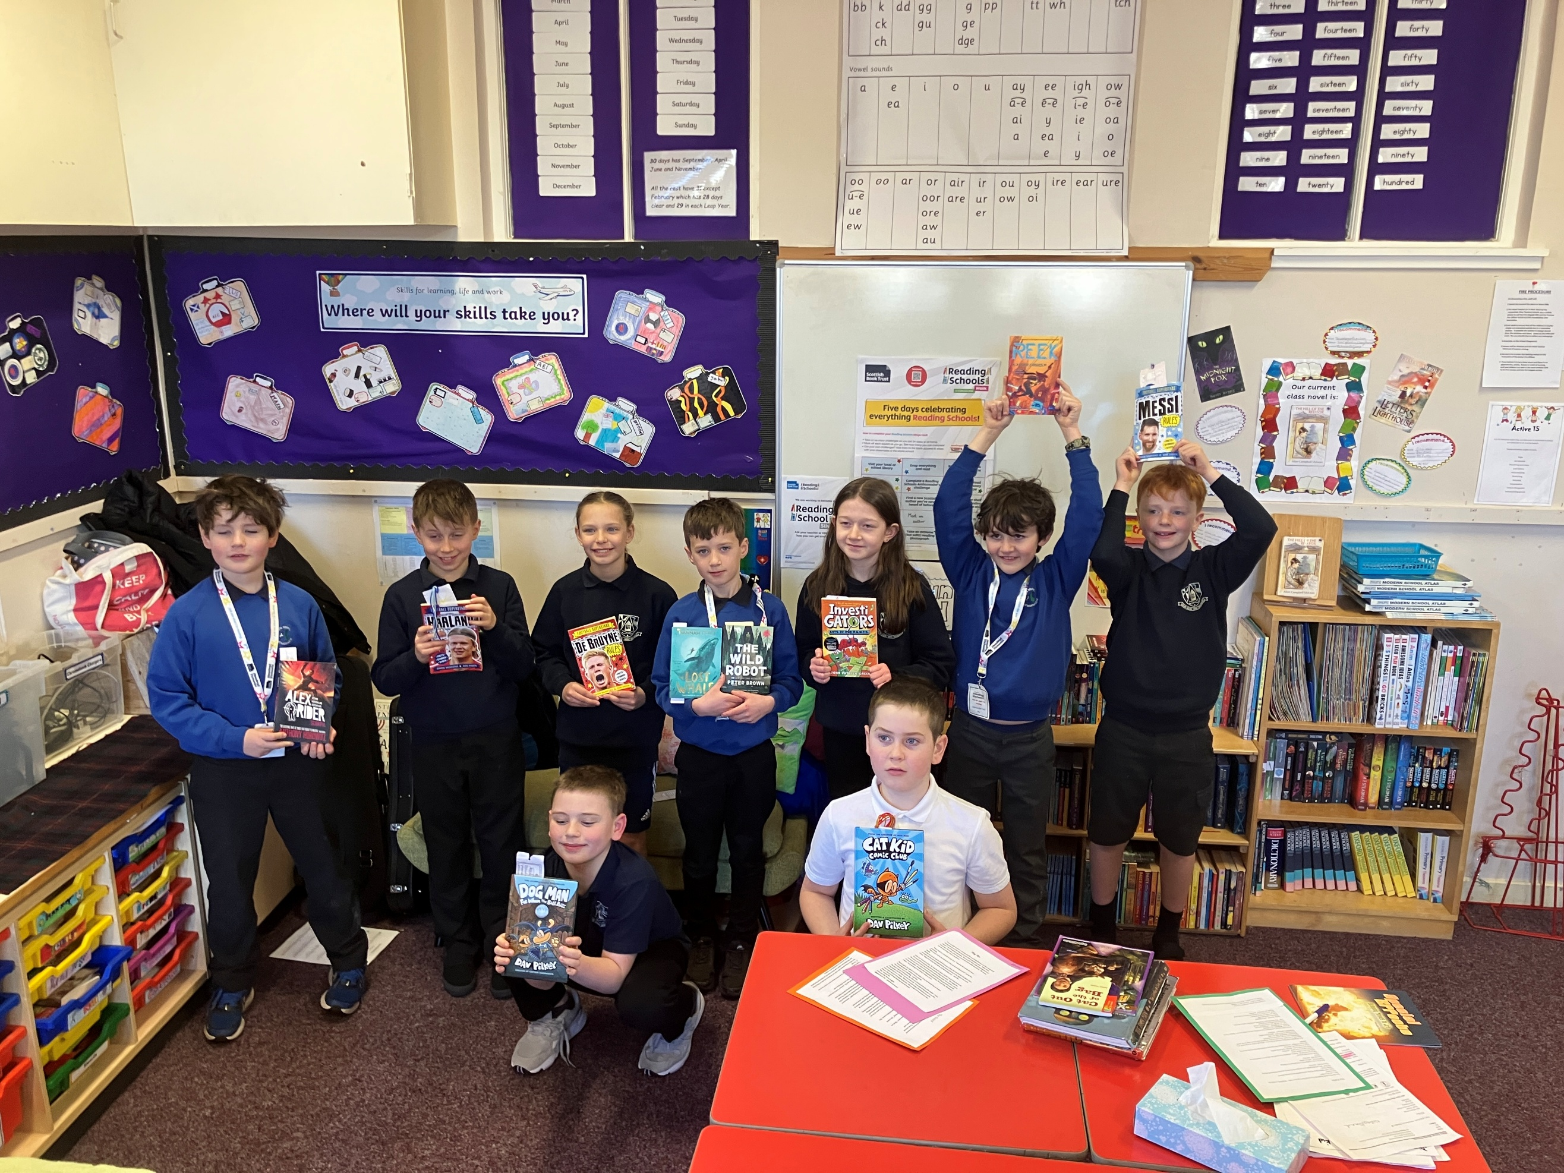
National Library of Scotland – Articles 30, 31 – We were chosen by the NLS to participate in an art project ‘Rain’ as part of an exhibition which is being displayed at the NLS. The project involved creating a piece of artwork and sharing our knowledge of the different Gaelic words and phrases we have for rain on Raasay.
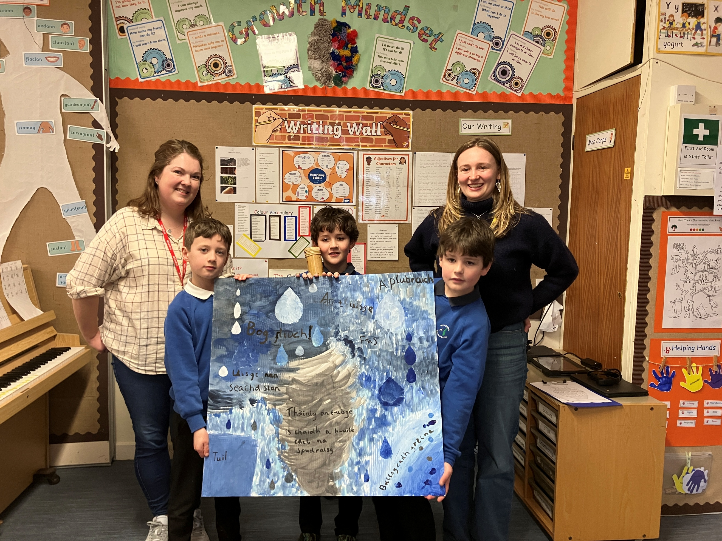

Pets as Therapy – Article 31 – We continue to enjoy our partnership with Freya (our therapet) She has become part of our Reading Schools partnership and we read to her regularly and her owner reads to us.
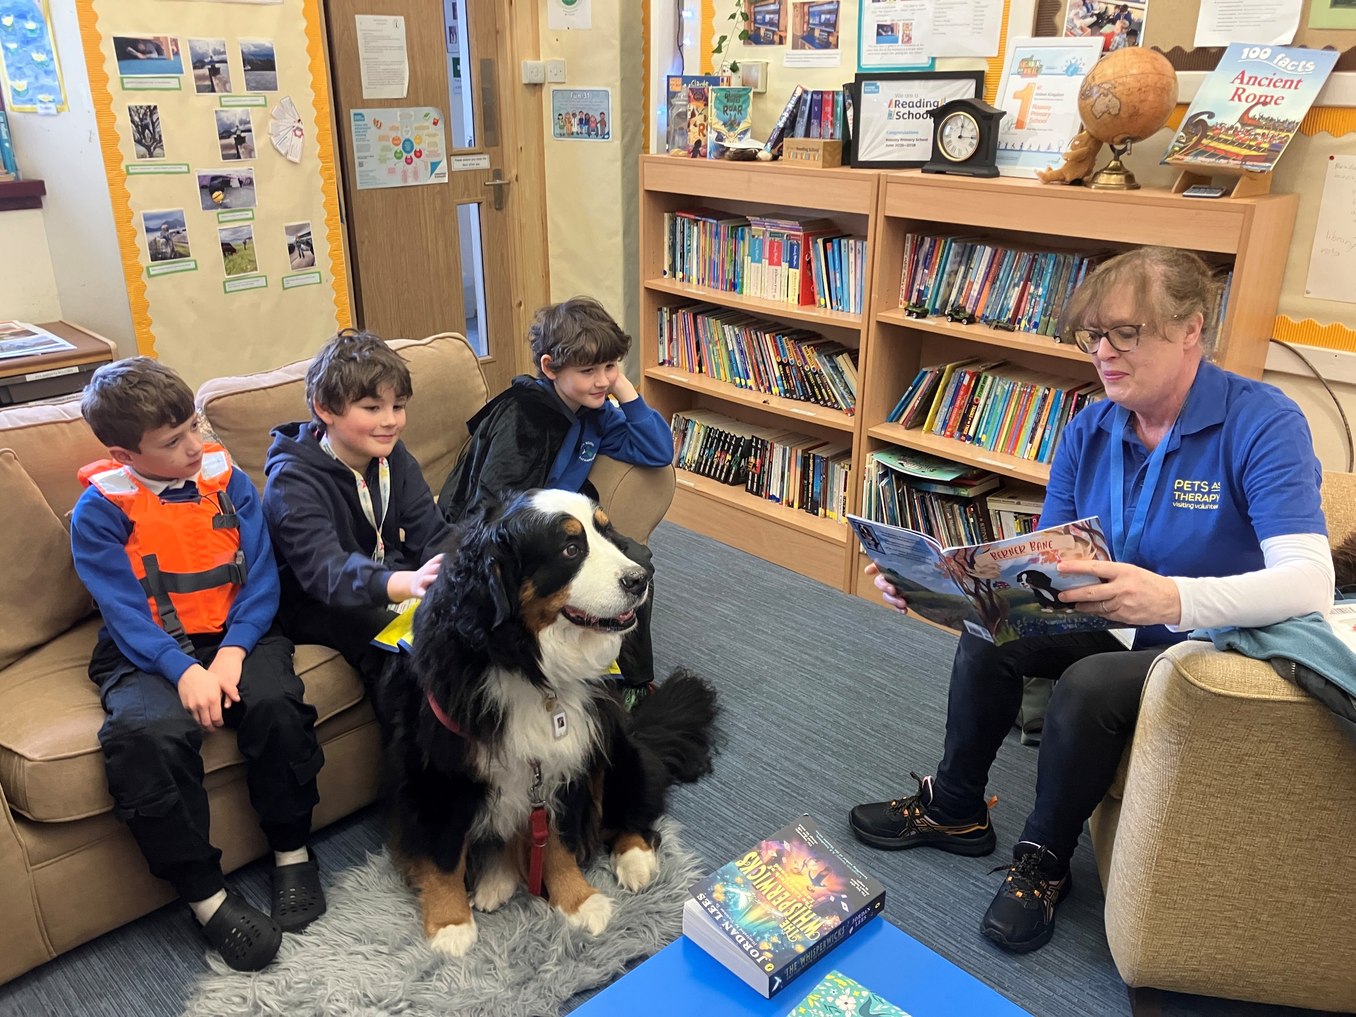
Beach Clean – Articles 12, 24 – As part of our eco work and Rights Respecting Schools, we identified a global campaign we have adopted a beach on Raasay which we will regularly monitor and maintain. We worked in partnership with MOWI and the Community Council. We wrote to MOWI to ask them if they could provide a boat to take away the rubbish and resources like gloves and litter pickers.
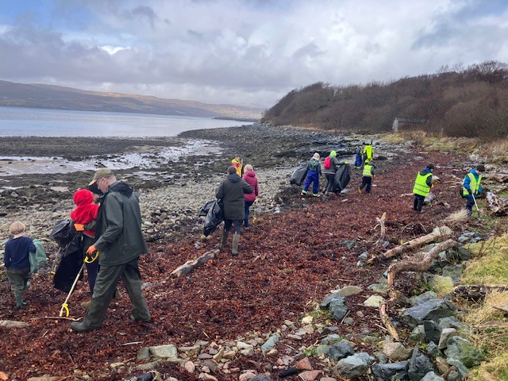
Kayaking – Article 4, 24 – Kayaking is part of our P.E. curriculum in terms 1 and 4. We build on our skills each term and share what we have learnt through having an end of session kayaking challenge as part of Sports Day.
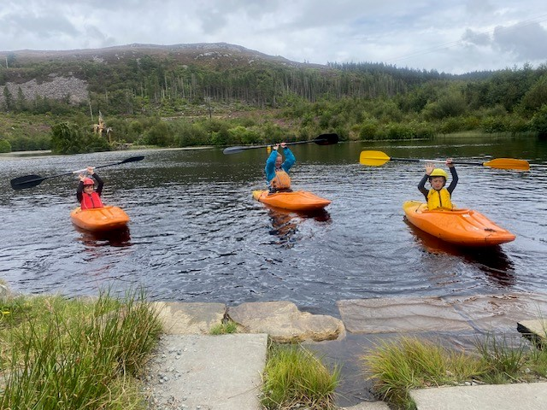

Book Bus – Articles 29, 31 – We started our Book Bus initiative this session in Nursery whereby we share our Reading Schools’ journey with the community by going out and about with our Book Bus to meet members of the community who read to us in the outdoors.
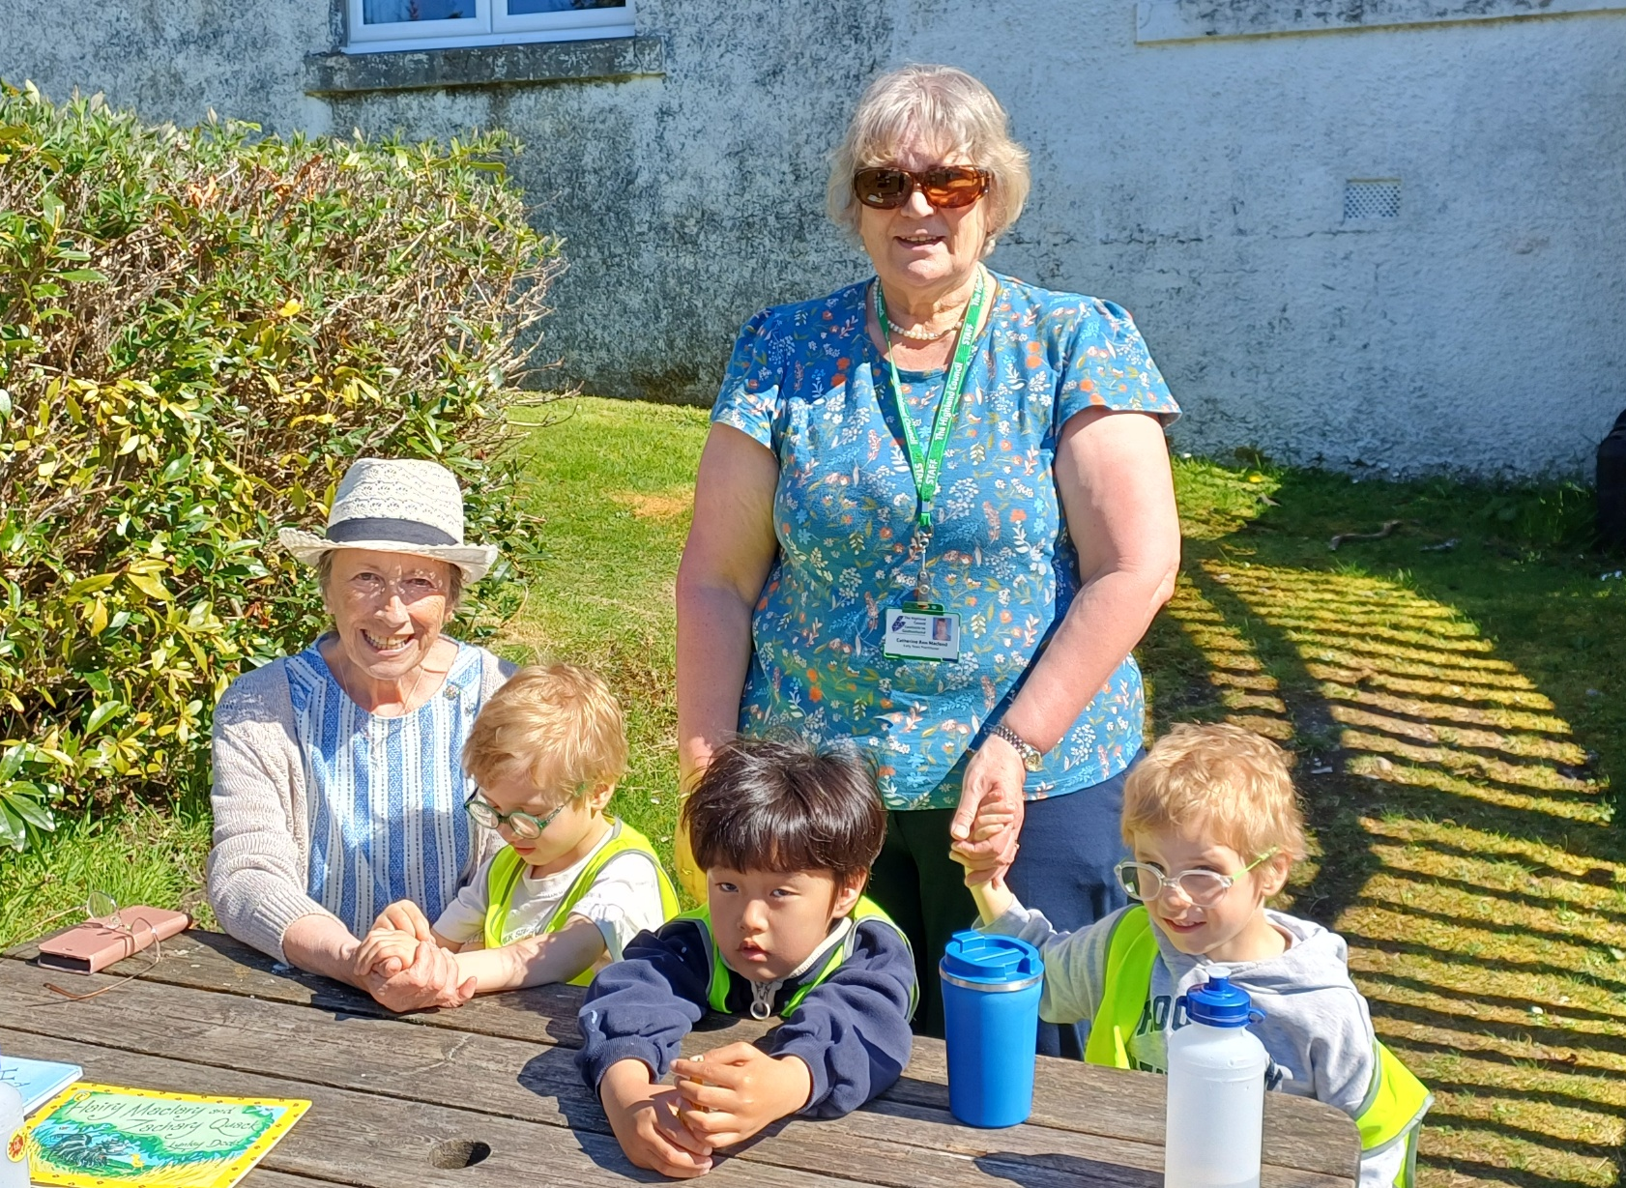
Article 31 Nursery pupils learning through play – Block Play. We are using our imagination and creativity with the block play resources. We have made a ferry, a rocket and a garage to name just a few things that we create.
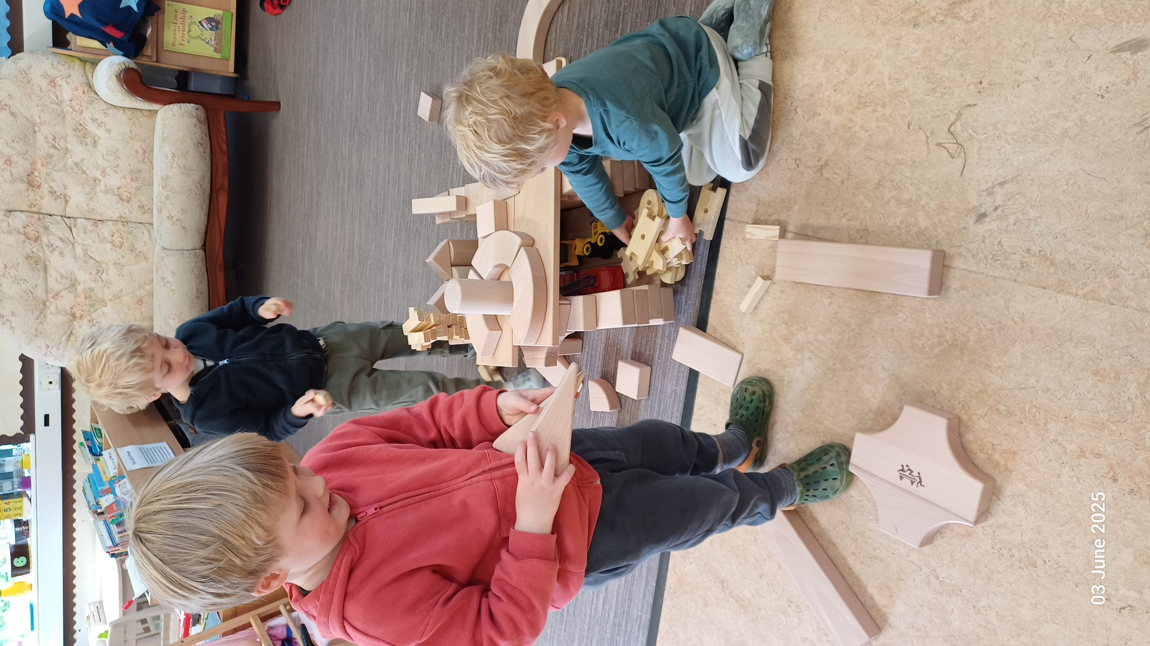
World Book Day Articles 29, 31 – We take part in the annual World Book Day event where we spend the whole day celebrating and sharing books, listening to stories on our new YOTI and watching Authors Live. We love to dress up and celebrate everything to do with reading.
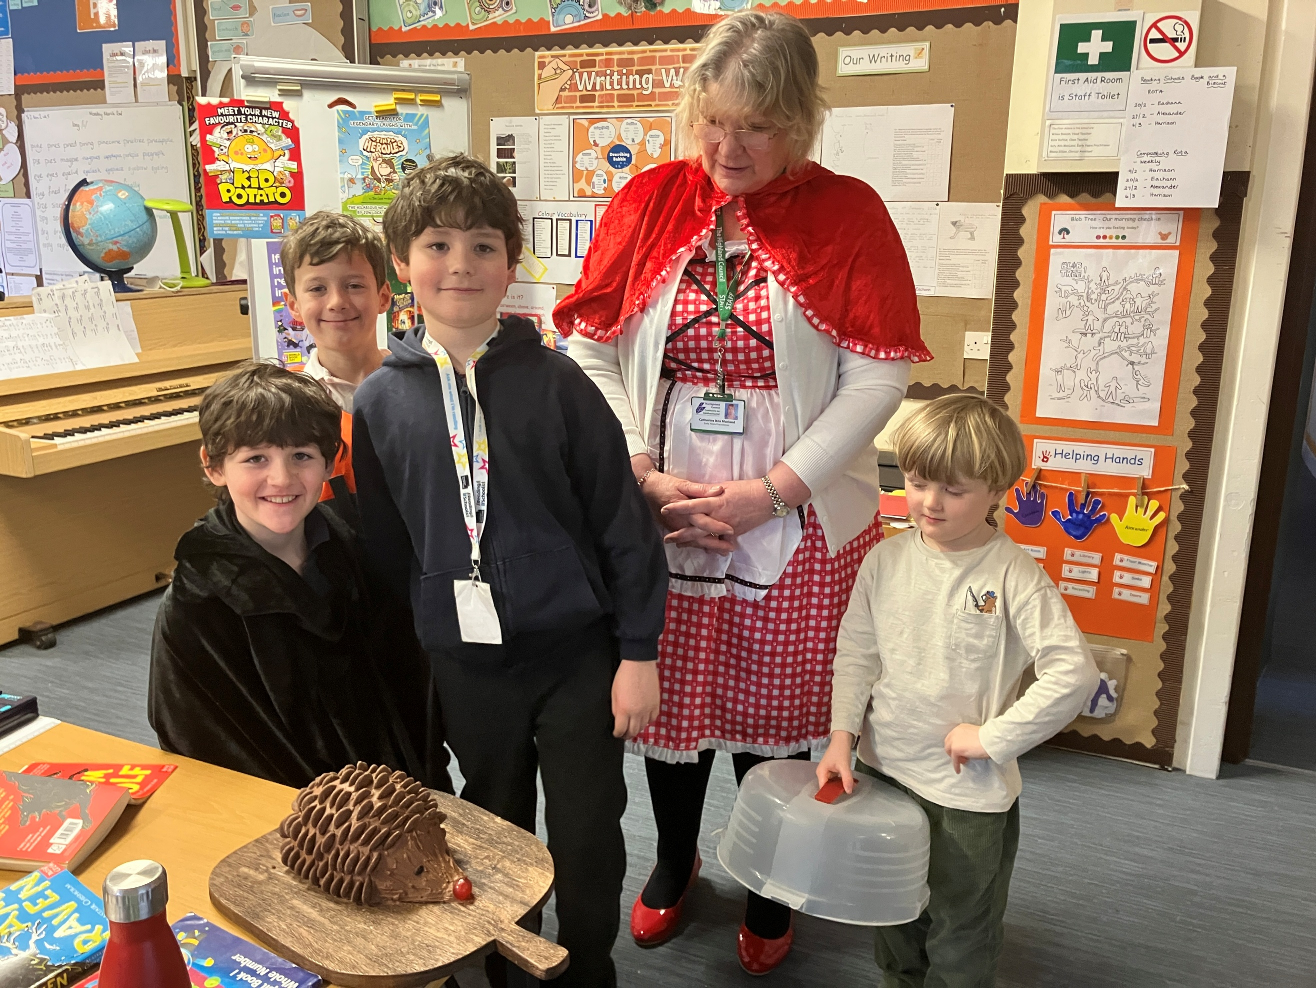

Comments from learners, families, stakeholders and staff
Beachdan bho luchd-ionnsachaidh, teaghlaichean, luchd-ùidhe is luchd-obrach

All children in the Nursery and School report that they enjoy coming to Raasay Nursery and School. They all shared their views by way of pupil surveys and during Learning Conversations and have detailed that they feel safe, are treated with respect and that the school helps them to understand and respect other people, that children treat each other with respect and that the school is helping them become confident individuals. Pupils also reported that the school teaches them how to lead a healthy lifestyle and that there are lots of opportunities for regular exercise. They all reported that the school offers them the opportunity to take part in activities in school and beyond the classroom and timetabled day. They all agreed that they have they have the opportunity to discuss their achievements out with school with the adults in the school that know them well. They all report that the school listens to their views and takes these views into account and that they feel comfortable approaching staff with questions or suggestions and that staff help them to understand how they are progressing in their schoolwork. Pupils also detailed that they are encouraged by staff to do their best all the time.
All parents strongly agree that their child enjoys being at school, and that staff treat their child fairly and with respect. They also all reported that they feel their child is safe at the setting and that the setting helps their child feel confident and that staff really know their child as an individual. All parents report that the setting encourages their chill to be healthy and take regular exercise and that the setting support their child’s emotional wellbeing. All parents strongly agreed that their child is making good progress at the school and nursery and that they receive regular, helpful feedback about how their child is learning and developing. Parents understand how the setting monitors their child’s progress and how progress is assessed. All parents report that the school takes their views into account and feel comfortable approaching the school with questions, suggestions or a problem and all feel that they are kept well informed. All parents report that they strongly agree that the setting is well led and managed and that the setting encourages children to treat others kindly and with respect. All parents are very satisfied with the quality of the teaching in the school and would recommend the setting to other parents. All parents detail that they are very satisfied with the setting.
All staff report that they strongly agree that they feel appropriately supported by the setting to undertake their role. They detail that they find it rewarding to be a member of staff at Raasay Primary and feel a valued part of the school’s community and are encouraged and given opportunities to learn and share practice with colleagues from other schools and ELCs. All staff also strongly agree that they have a clear understanding of the social, cultural and economic context of the setting. They all strongly agree that their professional learning enables them to reflect on and improve their practice, and they feel supported to engage in professional learning. All staff detail that they have regular opportunities to take on leadership roles and in agreeing priorities for the setting and are actively involved in the school’s ongoing self-evaluation against the professional standards and to support professional reflection and learning. All staff strongly agree that they use information including data effectively to identify and reduce inequalities in children’s outcomes and understand how to apply the setting’s procedures relating to child protection and safeguarding, school policies and that the school’s vision, values and aims underpins their work. All staff detail that they communicate effectively with each other and treat each other with respect, that staff treat all children fairly and with respect and that children are encouraged and supported to treat pupils and staff with respect. All staff strongly agree that setting is well led and managed and the setting’s arrangements for engaging with parents in their child’s learning is effective and report that collaborative working across the school is effective in taking forward improvement. They all strongly agree that children and young people are engaged in their learning and that children in the setting are engaged in their learning and provided with experiences which meet their learning and developmental needs. All staff detail that children are involved in talking about and planning their learning and targets and in leading their learning and are given regular feedback which helps them to progress. All staff report that the setting has effective strategies to support children and young people with their learning, including those requiring additional support and that they receive appropriate support for the plan, preparation and assessment of children’s learning and development. All staff strongly agreed that there is a shared understanding of their ‘responsibility of all’ in literacy, numeracy and health and wellbeing. All staff strongly agree that moderation activities help them to make sound professional judgements and that they have regular opportunities to shape the curriculum through discussions with colleagues, parents and partners and are aware of and involved in the setting’s strategies for raising attainment.

All staff detail that the collaborative working across the school is effective in taking forward improvements and that pupils are very engaged, and the setting is well led. Parents report positively about the school and continue to highlight that they appreciate the strong partnerships that exist between, pupils, parents, staff and the wider school community and island community.

All pupils report that they continue to enjoy eating the produce from the weekly veg box from the Walled Garden in their school meals.

The school benefits from huge support from the local island community not least by way of supporting our Pupil led ACORNS Enterprise Event which this year was our intergenerational curling event for the whole community. We raised £178.00 for ACORNS Pupil Council Fund. Our Annual Calendar is our main fundraiser for our School/Nursery Fund and raised £2000 through sponsorship from local businesses and groups and sales worldwide.
Fundraising across our various events raised £396.91 for Charity. We have worked to further embed the UNCRC Articles through the Silver ‘Rights Aware’ Award this year and have our accreditation interview at the beginning of session 206/27. As part of our work, we have had a local campaign whereby we ‘adopted’ the beach below the play park and had support from Mowi who brought a boat and resources to help us clean our beach with help from the Community Council and the community. Our global campaign has been learning about the work of UNICEF, and we undertook a school fundraising challenge to climb Dun Caan and spread the word on the importance of UNICEF from the highest point on the island. Our fundraising will continue until the end of this session and into next session when we will continue to support this important charity.

All pupils have reported how much they have enjoyed the Reading Schools Silver Journey this year and how they have ‘found’ their reading identities through the variety of initiatives the school has undertaken to support reading for pleasure within the setting. They value the initiative which they lead on and see how it has helped them to become more confident readers.

We continue to make the most of our unique island setting to develop opportunities for personal achievement eg: providing Kayaking lessons within P.E, developing the ethos and life of the school as a community eg: Eco work – beach cleans, charity work, ACORNS enterprise events, UNCRC, Reading Schools and supporting community events eg: ACORNS helping the Community Lunch Club to serve hot meals in the community hall. We continue to harness personal development opportunities whenever possible.

In April this year completed our Junior Dukes awards with pupils achieving in their respective bronze and silver categories – this is a home/school link project which encourages our pupils to identify, develop and reflect upon key skills across a range of experiences within their home and school life and will be an ongoing programme as part of Wider Achievement next year as the pupils move on to silver and gold awards.

All pupils report how much they a have valued all visitors to the school across the year, their collaborations with the small island schools: Eigg and Muck as part of their reading and UNCRC Journey and also their visits to other settings to support other schools with their reading journey in the ASG. The look forward to promoting the rights of others locally and globally through advocacy eg: rural transport and engaging in meaningful action with councillors and government

Quotes from pupils:
‘In Rights Respecting Schools we are working towards our Silver Award. We have adopted a beach and asked Mowi to help us by writing letters. They have a boat and litter pickers and gloves and we all clean it together. This was our local UNCRC campaign. Our Global Campaign was to raise awareness of UNICEF so we went to the highest part of Raasay to share how important UNICEF is for children. I really enjoyed doing this as it is important to raise awareness of children’s rights around the world. All in all, this entire year has taught me lots (LOTS) of amazing things.’

My most favourite part of this year was performing at the Mod. It was so fun and exciting and I feel I met all of my targets in this. The best part about it was when we went on stage and played three tunes and we sang songs including our school song ‘Tobhta Fearna’. I really enjoy when Freya comes in and we read stories to her and sometimes she reads to us! I am really enjoying the Reading Schools Award. I have gained more interest in reading books. At the moment I am reading The Last Bear.’

‘We also finished Junior DUKES!!!!! We have been working on it for over 10 months. I am really excited to get the bronze medal. It was really fun to do. I’m looking forward to working on my silver Award next year. It is really exciting when we have an online assembly with Egg and Muck. I enjoy helping other schools to reach their Reading Schools goal. My year has been really fun, exciting. I got to meet new friends and have learnt lots of new things. I am looking forward to being a P5 and for when the little children come into P1.’

Quotes from parents:

“My child’s love of reading has been fostered by the many wonderful initiatives that the school has to offer. He regularly asks if it’s “Book and a Biscuit” day and is always delighted when it is, often bringing his own books in that he’s been enjoying at home to share with the others. He also enjoys listening to story cards on his YOTO player and often taken it in to share with his peers. It is clear to see that these have had a hugely positive effect on his imagination and vocabulary.” Parent

"Our child has been very happy at Raasay Primary School and Nursery. As a family who moved from another country, we have always felt welcomed and supported by the staff and wider school community. The school provides a nurturing environment where children can develop confidence, independence, and a love of learning. We particularly appreciate the wide range of experiences available to the children, including outdoor learning and opportunities to engage with the local community. We are grateful for the dedication and care shown by all staff, and we feel our child is thriving both socially and academically."
Parent

“The Nursery is great, the boys love Katie Ann and Eilidh teaching them plus all school staff. Fantastic environment.” Parent

“Raasay Primary is a great learning environment. Pupils are supported to achieve to their maximum potential, and learning is enjoyable for the kids. Great extra opportunities for them.” Parent

‘My child has really enjoyed P6, especially having a starring role in the school play, completing the reading challenge and immersing himself in science and technology projects. He also enjoyed the theme of Ancient Greeks and was able to explore that on holiday visits to Athens and Mycenae. He is definitely ready for P7.’ Parent

‘My child has been given opportunities to really stretch himself this year in music, maths and reading and in doing so, has discovered new talents and gained a lot of confidence. He was rightly proud of himself for overcoming his fears and performing at the Mod. He is also getting a lot of joy and learning from the kayaking lessons with Ms Duffus.’ Parent

Quote from Parent Council

‘We feel it has been another brilliant year for the pupils of Raasay Primary & Nursery. They have not only made excellent progress with their learning, but they have also designed and participated in many events and activities with the wider community. As a Parent Council, we have really enjoyed supporting these opportunities and can see the benefits both for our children and for community members.’

Partners:
Sarah Ross Young Leaders and Curling - It has been great to work with the young leaders in Raasay primary. The three young leaders should be very proud of their curling sessions. They showed strong confidence when delivering activities, particularly when explaining the rules and demonstrating the skills. Their instructions were clear and easy for participants to follow. They were very encouraging towards all participants, offering positive feedback and support. They were keen to help everyone enjoy the experience, regardless of ability. I think what stood out for me was their enthusiasm to take on the challenge. They approached the opportunity with a great attitude and were fully engaged from start to finish. Over the course of the session, you could see their confidence grow as they became more comfortable leading the group and taking responsibility. Overall, they did a fantastic job and hope they will look to run some more sessions in the future.
Raasay Community Council – Beach Clean We, the Community Council, would like to thank you all for organising and undertaking the beach clean by the playing field on Wednesday 18th March. It is through initiatives like this and islanders willing to work hard that keeps our island such a beautiful place to live, work and visit. Well done to all of you and your teachers and helpers.
National Library of Scotland - Rain Project Thank you so much from everyone at the National Library of Scotland for making such a lovely artwork for our ‘Rain’ exhibition. It was so lovely to meet you all and hopefully you can come to visit us in Edinburgh next year. Sarah MacKay
Weaving - This past year, I was so pleased to be invited, once again, into Raasay Primary School to continue working with the three pupils on hand-weaving. I understand that the request came from the boys themselves, which demonstrates clearly their enthusiasm for continuing to develop their skills in this craft. These young boys are a delight to work with and the ambience which surrounds our Wednesday after-school class is so enjoyable. This year I have seen impressive progress in their work, and their ability to read and understand a weaving draft and work through it. They are now working much more independently with me mentoring as much as teaching. I hope very much that we will be able to continue to work together next session, expanding further their knowledge of weaving. Lillian MacLeod

Community Lunch - When the older ones are taking food orders and serving the food they are always so polite and this is constantly commented on.
It’s not always easy for them but they’ve grown to interact and are aware of the different needs of others - eg to ask if there are any allergy provoking ingredients for certain people.
They are always asked what’s in the soups and the puddings so given much of our food is locally sourced it involves talk around this which is lovely to hear. I have heard them telling the younger pupils when they all sit down to eat.
The nursery pupils we all love to have join us too. They eat such a variety of things and again they know exactly how to “eat out” in what is sometimes a busy place. It is a Community Lunch for all ages and I think we all benefit from the get together where everyone is included. It means too when out of school the children are happy to stop and engage in conversation- again a plus for all. Ann Oliphant

Mexican Artist Daniel and Katherine - Atlas Arts We were so impressed with the warm welcome at Raasay Primary and the pupils were engaged, enthusiastic and inquisitive – it made for a really fun and interesting session. Daniel said that he left the afternoon feeling inspired and uplifted and enjoyed the discussions with the pupils immensely. We hope to be back to visit again when Daniel is back in May.

Skye Alpacas
It was such a pleasure to introduce the alpacas to you all, I just wanted to comment on how well behaved and respectful the children were, I was particularly impressed by the well thought out questions the older boys asked. I look forward to welcoming you another time. Shona

Christmas Production – Calum’s Road
“Such an incredible performance by all, a thoroughly great evening and great to see so many people’ June Gosling
“Amazing everyone” Diana Lindsay
‘It was just wonderful’ Lesley Oliphant
‘It was a really super night. Children are amazing – as are the staff’ Ann Oliphant
‘A most entertaining, enjoyable and excellent performance – Thank you ALL’ Catherine Travis Timms
‘Thoroughly enjoyed it. Thanks to all’ Linsay MacLean
‘What can I say – that was the most well-rehearsed and professional delivery of a school play that I have ever witnessed, both in interpretation and delivery. Mrs Duncan, her staff team all have excelled themselves, and the community too in their help and input. (The mulled wine was a triumph!) A delightful evening. Boys reach for the stars, they are there but not always visible. You can do it! Thank you so much for inviting me and for arranging my accommodation so I could attend – it was very special. Julie (Calum the Road’s Daughter)
Piping Tuition
“The boys are all very nice boys and I really enjoy working with them. They are always well prepared for their lesson and take on instructions very well. They are willing to give things a go and to keep on trying until they get it and never just give up on it. If they keep on going they will be good pipers in the future.”
Angus MacPhee, Piping Tutor

Kodaly Music
“I have thoroughly enjoyed teaching the children of Raasay Primary school this year. I have provided a block of 10 Kodaly Music lessons online, each lesson lasting 45 minutes. The lessons are active, pacey and made up of a number of musical concepts including keeping a steady beat; listening to, copying, and reading basic rhythms (ta/ titi/ ssh/ tikitiki) ; learning pentatonic scale with solfege hand signs (drmsl); learning the elements of music including texture, tempo and dynamics; and playing games which incorporate and practice all of the concepts together. The children are fantastic learners; engaged, curious and eager to progress and improve, they relish challenges and always give their best efforts. This year we have made excellent progression in our music lessons. Communication with the school is always excellent and I have a good working relationship with the teachers and administrative staff. Thank you Raasay Primary School!” Nan Fee, Kodaly Music

MOWI Fish Farm
“It was a joy to work with the pupils and staff from Raasay Primary. There were no issues around communication, planning or timing for our beach clean. We would jump at the opportunity to work with them again.” John MacPherson, Farm Manager MOWI

Pet Therapy
‘When they were reading a book to Freya, the pupils adapted a character in the story of the Gingerbread Man from a fox to a dog to meet the needs of the dog! They engage very gently with Freya and she responds to their attention. We thoroughly enjoy our visits – I think it is beneficial to students to have a therapy pet. The nursery children over time have become much more engaging with her and particularly when we take her working jacket off and they can be more tactile with her. The nursery children have also become more calm and have come out of their shell with her. The older pupils also ask very interesting questions about Bernese Mountain dogs.’ Catherine Travis Timms, Pets as Therapy

Capacity for continuous improvement
Comas airson leasachadh leantainneach

Using indicators from ‘How Good is our School 4’ together with learner, parent, carer, partner and community feedback we believe we have made the following progress this session:

 | ELC | PRIMARY
QI 1.3  Leadership of change | Very good | Very good
QI 2.3  Learning, teaching and assessment | Very good | Very good
QI 3.1  Wellbeing, equality and inclusion | Very good | Very good
QI 3.2  Raising attainment and achievement/Securing children’s progress | Very good | Very good
QI  Partnerships | Very good | Very good

Our overall evaluation of our capacity for continuous improvement is:
We are confident in our capacity for continous improvement.

Key priorities for improvement planning
Prìomhachasan airson planadh airson leasachadh

Literacy - Reading Schools – Reading for Enjoyment across the Nursery and School Setting. To achieve ‘Gold’ accreditation by June 2027
HWB – UNCRC Rights Respecting Schools (Sliver/Gold) To achieve Silver (Rights Aware) by August 2026 To achieve Gold (Rights Respecting) by June 2027

Planning ahead
A’ planadh air adhart

Full details of the school’s 2025/26 improvement priorities and actions are detailed on the school improvement plan, which can be accessed on our website www.raasay primary.com or by contacting the school office.

